Eduardo  Negron |  | 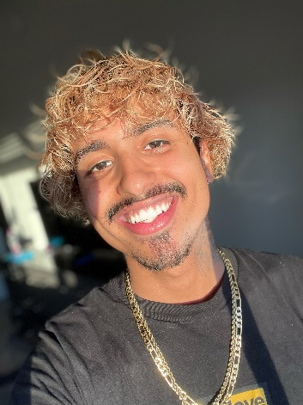

Experience
06/2019–11/2019
In the Heights • Sonny • Measure for Measure Theatre
12/2019–03/2020
Island Song • Cooper • Measure for Measure Theatre
06/2021
The Nosleep Show • Falcon • PlanetU4ia Productions
.

Education
Hallandale All-Magnet, Hallandale Beach, FL
- Received NBC’s Rise grant for production of ‘In the Heights’ where I was cast as ‘Benny’
- I am an inductee into the International Thespian Society

Appearance
Gender: Male Height: 5’10”
Weight: 147 Lbs. Ethnicity: Hispanic, Multiracial
Build: Toned Age Range: 18-26
Eyes: Brown Hair color: Brown

Special Skills
Fluent in English Strong Voice
Spanish Dialects & Impressions

References
Available upon request.
 |  | Contact
6923 W Sunrise Blvd Apt 308
Plantation FL, 33313
 |  | (954)997-6711
eduardofernandez0705
@gmail.com

