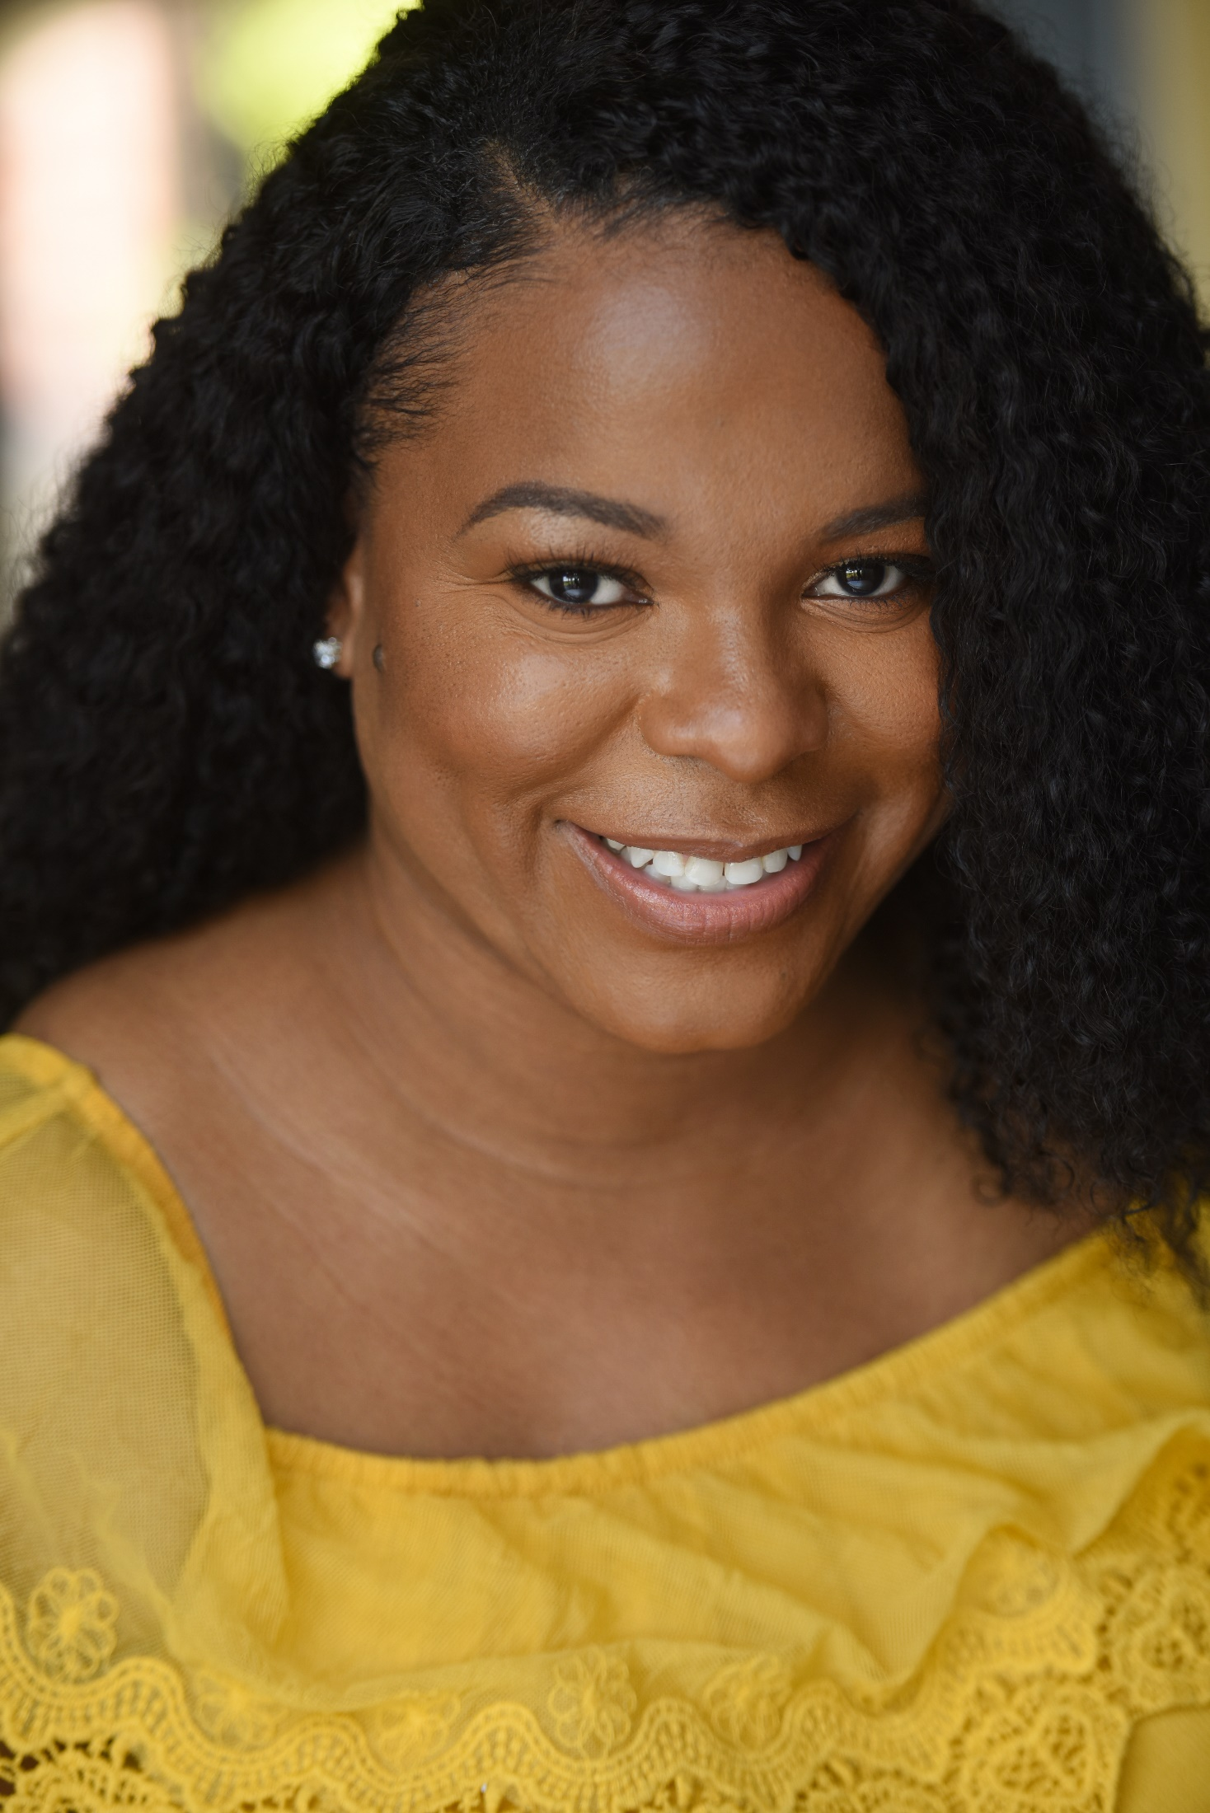
Autumn T. Wallace
Height: 5’ 2, Weight: 148lbs.
Hair: Dark Brown, Eye: Dark Brown, Voice: Alto
4800 Lyon Heart Drive, Unit L, Owings Mills, MD 21117
(443) 506-6170, awallacejd@gmail.com

Theatrical Credits_____________________________________________________________________

Film & Television:
Criminals at Work – Desperate Measures (Season 1, Episode 5); Black Entertainment Television (BET)
Casting: Sirens Media, 8403Colesville Road, Suite 1600, Silver Spring, MD 20910
Directed by Justin Wolfe [09/14/15 – 09/17/15]
Aired: January 20, 2016 (BET)
Role: “City Capital Accountant #1”

Theatre:
For Colored Girls - Baltimore School of the Arts
Directed by Community Theatre Group [Spring 2014]
Role: “Lady in Yellow”

The Gnadiges Fraulein by Tennessee Williams - Morgan State University
Directed by Clinton Johnson [Fall 2000]
Role: “Polly” (Lead)

Get Witched Quick by David Rogers – Washington High School
Directed by Suzette Simmons
Role: “Junelle”

Voiceover & Public Speaking Experience:
Morgan State University – Speech and Debate Team
Dramatic Improv/ Dramatic Duo [2000-2003]
18 Awards Received (3- 1st Place, 7- 2nd Place, 6- 3rd Place and 2 Honorable Mention)

Morgan State University, McKeldin Center
Mistress of Ceremonies- Golden Key Honor Society Annual Banquet

Washington High School [1998-2000]
Anchor, Reporter & Writer for WHS TV [Public Access News Station w/ bi-weekly broadcasts]

Education and Training________________________________________________________________

Me, My Dreams and I – Audition Virtual Bootcamp
- Acting Coach/Actor – Darik Bernard; March 9th - March 30, 2021

Taye Tackles Acting Tactics – Varsity Tutors Virtual Training/Q&A
- Taye Diggs – February 20, 2021

University of the District of Columbia David A Clark School of Law, J.D. - Law
- Trial Advocacy, Trial Ad Seminary and Keys to Effective Courtroom/Public Speaking

Morgan State University, B.A. – Film and Television Production/Communications Major, Political Science Minor
- Public Speaking Platform Training, Oral Efficiency Seminar, and Performance Workshop

Washington High School, H.S. Diploma – College Prep
- WHSTV-News Anchor, Drama Club, Dramatic Art Clinic and Future Thespian Award 1999, 2000

