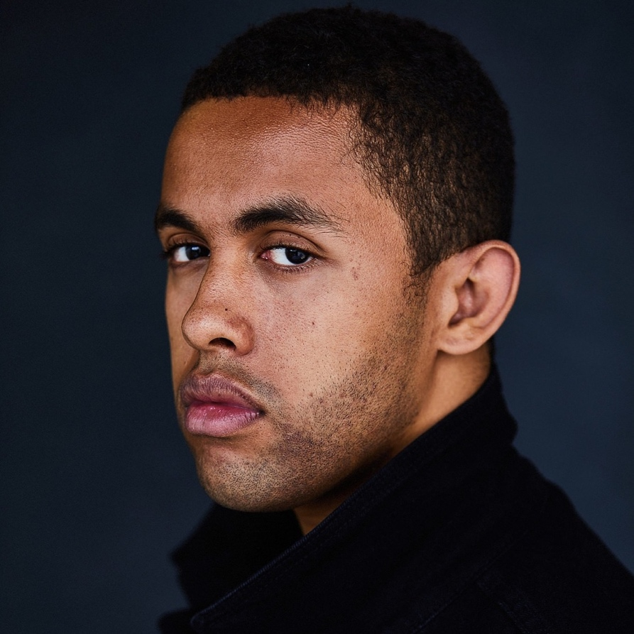
CV

Name: Henry Pyne
Date of Birth: 9/10/1998
Telephone No: 07555 449103
Email: hennerspyner@gmail.com
/Henry.Pyne2019@rwcmd.ac.uk
Address: 13 Llys Y Gored Ddu Off,
Blackweir Terrace, Cardiff CF10 3EX
[Home Address: Lobden, Upper Colwall, Malvern,
Worcestershire, WR13 6PY]
Currently at Royal Welsh Conservatoire:
Studying vocal and operatic studies (this course covers opera, musical theatre and acting)
Living In Lockdown
Lockdown was extremely challenging; however, I was lucky and found a lot of opportunities some of which included: Choir recordings for St Pauls Cathedral, Online sessions with the fantastic Dean John Wilson and his VC8 Pro doing acting through song, collaborations with fellow students to produce two choral videos directed by Thomas Mottershead, Masterclasses with the National Student Operatic Society and getting to perform for Austin Gunn.
Writing and recording my new monologue making chocolate brownies, Collaborations with Opera North Youth Group, 1 to 1's with Martin Pickard, being part of The Choir Of Solidarity Project, Musical Theatre Project Under the Spotlight led by Andy Reiss and Katie Leeming. With projects like Hamlet coming up I'm excited to continue developing as best I can. I've also recently completed two brilliant masterclass courses conducted by The Actors Warehouse lead by Studio Annelise Bianchini and Director Steven Bowyer.
Musical Theatre/Acting Experience:

- Malvern Theatres Young Company: cast member for 5 years appearing in Les Misérables, Jesus Christ Superstar, Oliver! Seussical and Guys & Dolls
- Hereford Gilbert and Sullivan Society: Patience
- Xentricity - Grease Lighting: Courtyard Theatre Hereford
- Acting Experience: As an extra in the Netflix series Sex Education!

DBS certificate for work as Tenor Lay Clark at Llandaff Cathedral which involves working with boy and girl choristers.
Choral Scholar at Hereford Cathedral – September 2018 to July 2019 Role in the Cathedral choir principally involves singing 8 services a week with three on a Sunday Eucharist, Choral Matins and Evensong. Additional work with choristers doing chorister lunch supervision on Sundays and helping run theory classes.
Choral scholar at Carlisle Cathedral - September 2017 to July 2018.
- Role in the Cathedral choir principally involves on weekdays singing evensong late afternoon and on Sunday morning eucharist and early afternoon evensong. Also working with choristers and organising chorister tea.
Musical Qualifications:
- Singing: Recently achieved my ARSM diploma, in which, I received Merit
- Clarinet: Grade 7 (ABRSM Grade 7 merit).
- Violin: Grade 7 (ABRSM Grade 7 pass).
- Music Theory: Grade 6 (ABRSM Grade 6 Pass).
Music Experience - classical
- While at Hereford Sixth Form College I was a Choral Scholar and tenor voice member of the semi-professional Academia Musica, directed by Aryan Arji. Experience included weekly evensong and rehearsals in Hereford Cathedral, performances such as the Bach B minor Mass, and annual tours to Dublin, Belfast, London and Cambridge
- Other experience includes
  - Hereford Three Choirs Festival Chorus 2019 performances with The London Philharmonic Orchestra as well as 2 BBC broadcasts with the Three Cathedral
Choirs
  - Whilst at Hereford Cathedral I was also fortunate to sing at Bayeux Cemetery for the 75th Anniversary of D-Day broadcast live on BBC Television
  - Hereford Three Choirs Festival Youth Choir including the Bernstein Chichester Psalms and The Chilcott Requiem mass and the 30^{0th} Anniversary Celebration performance for HRH The Prince of Wales.
  - Soloist in the 2017 world premiere in Colwall of Liz Johnson’s Requiem for Aleppo

