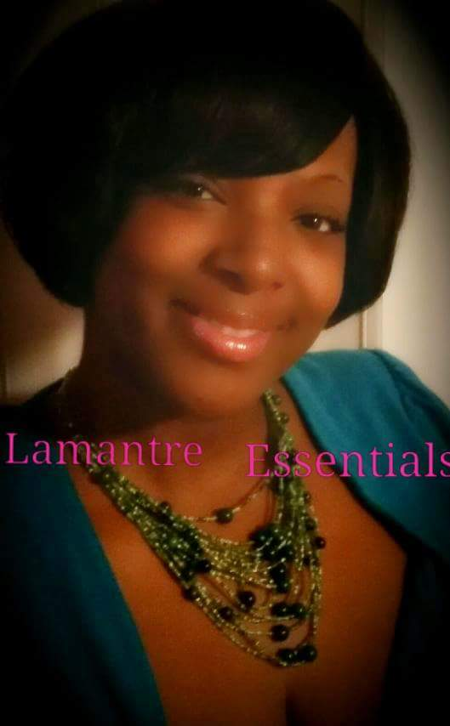 **LATONYA COOPER WILLIAMS**

404-484-7290

LcooperLcooper@yahoo.com

**FILM**

The Creeps Loud Lady in the club Origin Nile Studios Nicole Parker

**WEB SERIES**

ADULT VIBES Host Origin Nile Studios  
  
**THEATER**

Jonah and the Whale Tirana Civic Center - David Williams  
Stop Playin Leslie Origin Nile Studios - Latonya Cooper Williams

**TRAINING**

Acting Origin Nile Studios. Nicole Parker   
**SKILLS**

SKILL 1:Playwriting: “STOP PLAYIN”…”YOU NEED TO WHOOP YO KIDS”

SKILL 2: Acting,

SKILL 3:Modeling, Femi Wear,Photo Genic Inc.Immex Hair Solon Hair show and Up and Coming All shades are beautiful

SKILL 4: Singing

SKILL 5:Instructor Barbizon Modeling School

Skill 6: Director and Producer