**Nathan Scott**

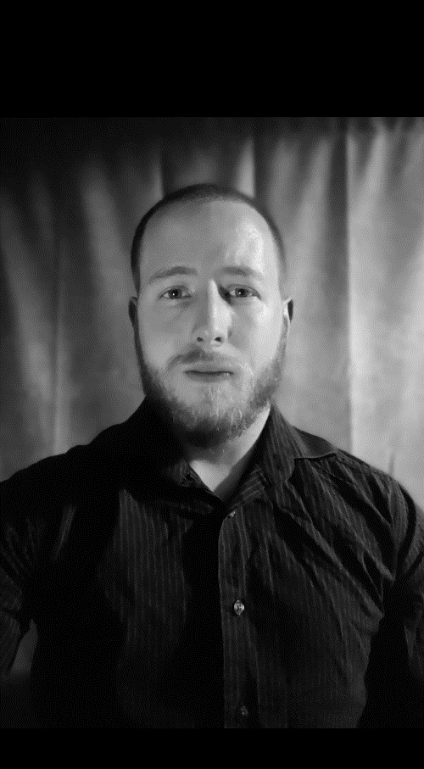**__________________________**

**Email Phone**

[Velsaga_@hotmail.com](mailto:Velsaga_@hotmail.com) 905-449-6320

**Address**

9 Brock Street East, Oshawa, Ontario, Canada

**Height: 5’7**

**Weight: 170 LBS**

**Hair: Dark mix blonde**

**Eyes: Green/Blue**

**Language: English**

**Special Skills**

**___________________________**

**Manual/Standard Driving**

**Weapon Handling**

**Military Experience ( Ongoing )**

**Goals and Desired acting opportunities**

**___________________________**

**New face and experience to film and or TV, career desired in far future and past era type TV and Film settings. Commercial, Action, Horror, Thriller, Psychological, Fantasy, Medieval middle ages opportunities.**

**COVID19 Vaccinated February 2021**