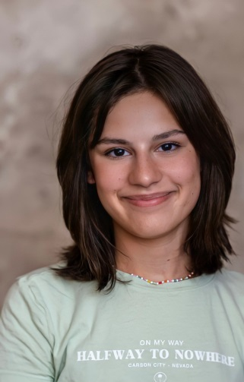

**"Creative Studio Magic"** - 5+ years

Finished Online Course **"First Steps"** - 6 months

Acting, Dancing, Improvisation, Painting, Drawing, Volleyball, Skiing, Snowboarding, Iceskating, English language, Serbian language, Videoediting, Art, Photoshop, Croatian language, Different dialects ( British, Irish, Scotish, LA, Canadian...) Gymnastics, Soccer, Swimming, Running, Hula Hooping, Stand-up Comedy, Hosting, Fast Learner, Working in team

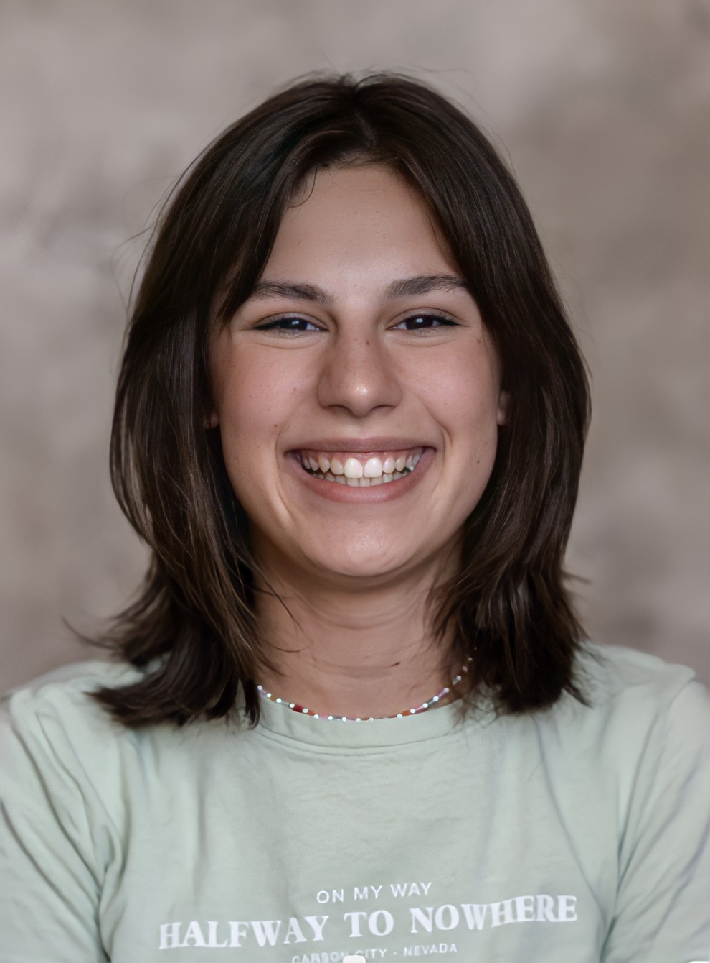

**EMAIL:** sarabunjevcev@gmail.com

**PHONE:** +38162/1798183

**INSTAGRAM**: @sarabunjevcev

**Special Skills**

*( worldwide )*

Non-union

"The Teacher" a student Natsa Vujovic Tomicic

"Our Dear Uncle" a niece Aleksandar Balos

"The Diary of Anne Frank" Anne Frank Natasa Vujovic Tomicic

**Theater**

**Training**

**Height :** 166cm / 5'5"

**Weight:** 52kg /144lbs

**Eye color:** brown/black

**Hair color:** brown

**Physical Attributes**

**SARA BUNJEVCEV**

**Cover Letter:**

Hello, dear reader, my name is Sara Bunjevcev. I am 13 years old. Acting is my passion and I have been attending acting classes for almost 6 years now. When I was younger I loved to impersonate my family members so my grandad ones told me I should try acting. I loved that idea and begged my dad to sign me into an acting school. The first class passed amazing and I fell in love with it, and I fall more and more every day. When one of my friends first joined the acting class, teachers asked her why does she want to be an actress. She said: “ When I was younger I wanted to be a lot of things...singer, vet, doctor, hairdresser, lawyer...but then I realized that with acting, I can be all that and even more.” I think that’s when it hit me. I felt every word she said and I immediately knew - this is what I want to do for the rest of my life. I would lie if I say I didn’t think about it and didn’t hesitate many more times. But just like that I also had many more moments when it hit me again. So yeah, it is what I want to do and I will pour my heart and soul into it.