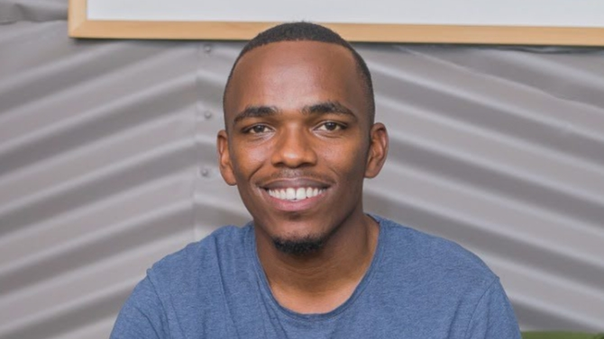Stephen Kamunya Mwangi

**Email**  **Phone**

## stevnsk@gmail.com 0729217647

**Bio**

**Eye Color**:Brown **Height**:5’7”

**Hair**:Black **Weight**:65kg

**Playing Age:**19-25

**Theater**

Year Role Production Director Company

2015 Biko(Lead) KnockOut Peter Tosh Liquid Arts Ent.

2015 Soldier(supporting) Centurion Peter Tosh Liquid Arts Ent.

2015 Kapul (lead) SideKick Peter Tosh Liquid Arts Ent.

2016 Jacke(lead) El Centro Peter Tosh Liquid Arts Ent.

2016 Kaput(lead) The Kaput’s Peter Tosh Liquid Arts Ent.

2016 (lead) City Train Peter Tosh Liquid Arts Ent.

2016 Obadiah Chorea Peter Tosh Liquid Arts Ent.

2016 (lead) Santa Jangili Peter Tosh Liquid Arts Ent.

2017 Salim(lead) Msaliti Peter Tosh Liquid Arts Ent.

2017 Pastor(lead) Secret sins Peter Tosh Liquid Arts Ent.

2017 (Supporting) Fist Fight Mark Munyiri Liquid Arts Ent.

2017 Ben(lead) Mkombozi Peter Tosh Liquid Arts Ent.

2018 Uncle J(lead) Ring&Bell Mark Munyiri Liquid Arts Ent.

2018 Peter(lead) The Cross Mark Munyiri Liquid Arts Ent.

2018 Chief Okolo(lead) Sabotage Mark Munyiri Liquid Arts Ent.

2018 Dr.Frank(lead) Hood Wink Mark Munyiri Liquid Arts Ent.

2018 Philip(lead) Tick Tock Mark Munyiri Liquid Arts Ent.

2018 Joseph(lead) Maria Peter Tosh Liquid Arts Ent.

2019 Sean(Lead) Tricher Peter Tosh Liquid Arts Ent.

2019 Rood(lead) Dream of Rood Peter Tosh Liquid Arts Ent.

2020 Chief(lead) The Golden Jar Peter Tosh Liquid Arts Ent.

**Production Credits**

Liquid Arts Entertainment:-

-Awarded Best Overall Actor of the Year (2016). “Stephen Mwangi has been able to exemplary showcase good craftsmanship and surpassed rules of creativity as a thespian.”

-Awarded with the Certificate of Merit at the Kenya International Theatre Festival.(2018)

**Web/online-Media Training**

-WhatCouplesDo 254 (YouTube Channel) -Attended Liquid Academy of Creatives(2016)

**Commercial**

-Available upon Request.

**Special skills**

-Singing (Tenor) -Improvisation

-Accents:Briton,South African

**Other Skills**

-Voice Actor.

-Experienced in Directing. Directed God’s Squad Play in Ack Church BuruBuru,Nairobi. (2019)