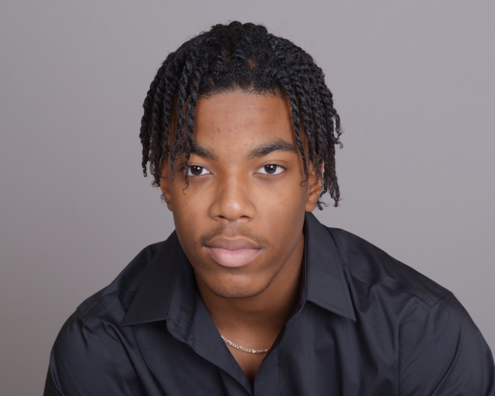

***Rahim Dunston***

***Buffalo, New York***

**(716) 444-0466** Email: [rahimdunston@gmail.com](mailto:rahimdunston@gmail.com)

**Height: 6’1” Weight: 165 lbs. lean, athletic build**

**Eyes: Brown Hair: Black**

**SPECIAL SKILLS:**

* **IMDb credit**
* **Actor- acting, movement, voice, stage combat, impulse improvisation, mask, directing, play writing, etc.…**
* **Musician (Professional Violinist), Pianist, Trombonist, Tenor Singer**
* **Martial Artist (2nd Degree Black Belt in Tae Kwon Do) and certified in 3 weapons**
* **Monologues and Oratory**

**FILM & TELEVISION ROLE**

***TV SERIES 2020 S1 (For Life)- ABC American Broadcasting Company*** *\**NU Student w/backpack

***TV SERIES 2019 S2 (FBI )-CBS Columbia Broadcast System*** *\*High School Student*

***FEATURE FILM- Adios Friend*** *\**Club Goer Scene*a* Sundance Institute Independent feature film

***COMMERCIAL- New York State Tourism*** * Whirlpool Jet Rider

***MOVIE – Hope for Christmas*** * Teen Violinist S & G Entertainment

***SERIES – Daddy’s Girl Club*** * Young Stephen Alemaedae Theatre ***(Streaming on SkoVu TV)***

**THEATRE (Musical Theatre & Stage Plays) ROLE**

***Stage Play- Pipeline \*****Omari*

***Stage Play- A Midsummer Night’s Dream*** *\**King Theseus

***Musical Theatre- Les Misérables*** *Bamatabois, Prouvaire (2019 Outstanding Musical Production Kenny Award Winner)

***Stage Play- After Ashley*** *Justin

***Stage Play- The Laramie Project*** *Aron McKinley, * Philp DuBois, Conrad Miller, * John Peacock, * Father Rodger Smhit

***Stage Play – Layla’s Room performed at (Subversive Theatre)*** * Reece

***Musical Theatre- Chicago***  *Ensemble

**TRAINING;**

**\*University at Buffalo (BFA Theatre)**

* **Prof. Vincent 0’ Neill (Director of Theatre Performance)**
* **Prof. Kathleen Golde**

**\*Buffalo Academy for Visual & Performing Arts Theatre (Elementary & High School)**

**-Graduate 2020**

* **Ms. Kelly Bueth**
* **Mr. Andrew Kottler**

**\*New York State Summer of The Arts (Theatre Program) NYSSSA Pre-Professional Training**

* **Artistic Director –Margaret Denithorne ( Peg)**
* **Guest Broadway Performer- Stacey Linnartz**
* **Voice Instructor- Neil Hartley**
* **Acting Instructor- James Luse**
* **Improv Instructor- T Valada Viars**
* **Scene Coach- Lydia Kubiniec**
* **Movment Instructor- Nicholas Khor**

**\*Paul Robeson Theatre Class & Coaching**