VICTORIA PARRIS

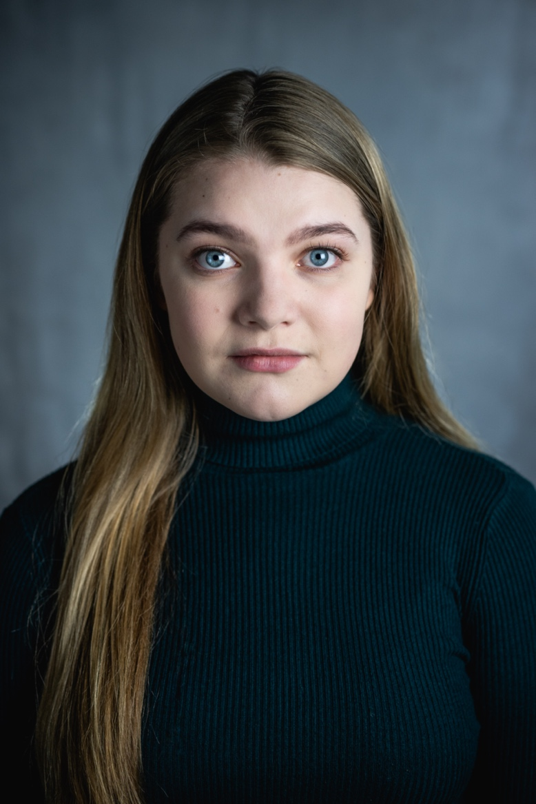
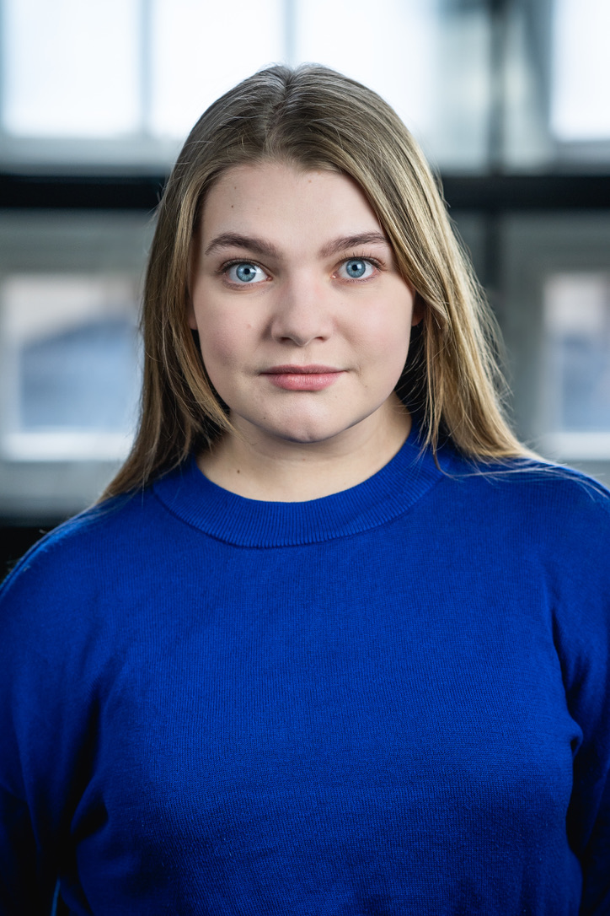

PLAYING AGE-16-25
HAIR- Blonde
EYES- Blue
HEIGHT- 5’4
ETHNICITY- White
BUILD- Curvy Athletic
Nationality: British

TRAINING

- A level Drama
- LAMDA training
- Degree in Acting for Film (Chichester University)

SKILLS

- Singing.
- Fist fighting
- Periodic Dancing.
- Sword and dagger fighting
- Horse-riding
- Voice over
- Swimming

ACCENTS

- Southern English (RP)
- Russian
- Northern Irish
- Standard American
- Southern American
- Essex
- Cockney

Short films-

Stop and Search | 2017 | Girl 1
Cyber Crime | 2017 | Georgia
Little Red | 2018 | Little Red Riding Hood
Force of Attraction | 2020 | Sarah
Why Can’t I Remember? | 2020 | Joanna
The Call | 2021 | Faith
Therapy | 2021 | Morgan
Daz’s Boot | 2021 | Jilly
Dog Days | 2021 | Kat

Plays

Into the Woods | 2017 | Lucinda
The Tempest | 2017 | Alonso
Nell Gwynn | 2018 | Thomas Killigrew
Mary Shelly | 2018 | Claire Clairmont
Much Ado About Nothing | 2021 | Beatrice

Contact details-

Email- Victoria.parris@aol.com
Phone- 07748986132

Showreel-

https://youtu.be/dQNeMFuYvkE

