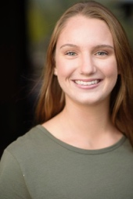

**JADA JO WARNER**

NON-UNION

**FILM**

THE BENCH

BURDEN

AMERICAN UNDERDOG

Lead

Dir: Lead

Dir: Extra

Dir:

Dir: Dir: Zachary Kelly

Dir: Dir: Erin Koopman

Dir: Dir: Erwin Brothers

**COMMERCIALS**

DICK’S SPORTING GOODS

Daughter

Haworth Marketing + Media

**EDUCATION AND TRAINING**

BACHELOR IN THEATER,

EMPH. IN ACTING (ONGOING)

University of Southern California

M. SCENE STUDY

Dearing Acting Studio

Matthew Dearing

IMPROV

SCRIPT ANALYSIS

Dearing Acting Studio

Dearing Acting Studio

Brian Sweeney

John-Luke Grubb

ON-CAMERA AUDITION WORKSHOP

Garth Williams Casting Garth Williams

**SPECIAL SKILLS**

Singing: Alto; Dancing: Musical Theatre, Contemporary, Line/Country; Athletics: Swimming (breaststroke, backstroke, butterfly, freestyle, distance), Cheerleading, CrossFit, Yoga, Weightlifting, Gymnastics, Running, Hiking; Ukulele; Videography; Video Production; Social Media Marketing; Photography; Driving, Cooking, Skydiving.