TJ  Stukes |  | 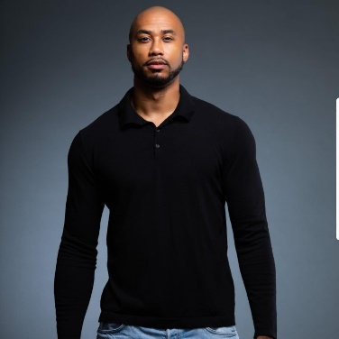

Movies
Valentine’s Date • Role: Uncle Glen • January 2021
Blackjack: The Jackie Ryan Story • Role: Principal Background • September 2019
Just Wright • Role: Principal Background • June 2010

Television
- Chicago P.D. (Season 7)-Principal Background
- Singled Out-Principal Background

Commercials
- Scalp Micro-Principal Background-March 2020
- Arm and Hammer-Principal Role-July 2019
- Adidas Lifestyle-Principal Role-April 2019
- Verizon-Principal Role-March 2019
- Lowes March Madness-Principal Role February 2019

Upcoming
A Game of Chess • Role: Lead • Releasing 2022

References
[Available upon request.]
 |  | Contact
5413 Vancouver Street
El Paso, TX 79924
 |  | 929-310-8331
 |  | Tjstukes2027@gmail.com

