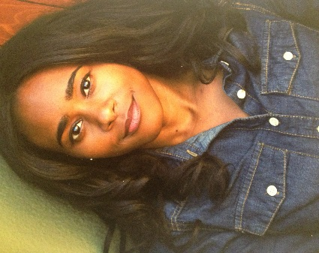TARA VAUGHN

[Tcvaughn1@gmail.com](mailto:Tcvaughn1@gmail.com) HEIGHT 5’2” HAIR: Dark. Brown Eyes: Dark

**FILM**

Abstract Featured UNLV Student Film

The Poet Music Video Supporting UNLV Film Production

I, Madeline Candice Deena James Company

**Commercial**

Pocket Flosser Principal 8:45a Productions

**INDUSTRIALS**

Resource Protection Featured U.S. Park Services

Lyft Zombie Mode Zombie Maude Lyft / Skybound Entertainment

**THEATRE**

Lysistrata Theban Woman University of Las Vegas Nevada

A Midsummer Night’s Dream Mustard seed Metropolitan State College

Throwing Your Voice Lucy Metropolitan State College

Assembly Line Marsha American American Academy of Dramatic Arts

Once In A Lifetime Phyllis American Academy of Dramatic Arts

Second Prize: Two Months in Leningrad Mary Alice American Academy of Dramatic Arts

Juvie Pinky Smoky Hill Theatre Production

The Crucible Rebecca Nurse Smoky Hill Theatre Production

**TRAINING** B.A. Acting/theatre and film University of Nevada Las Vegas

Acting: Brian Landis Folkins Denver Center), Nate Bynum, Clarence Gilyard, Michael Tylo (UNLV)

Voiceover: Sally Clawson & Tom Chantler (Voice One San Francisco) Improv: Shelly Gossman (UNLV from second City)

**SPECIAL SKILLS:**  Tap dance, Running, Volleyball, Jazz, wardrobe Stylist, Bowling, weight lifting, yoga, improvisation, Zombie Accents: British