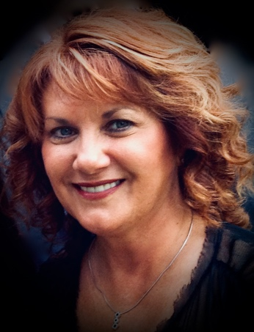    Desiree (Desi) Thrower desithrower@yahoo.com
408-220-4081

HEIGHT: 5’3”
BUILD: Hourglass
HAIR: Reddish/Auburn
EYES: Green
PLAYING AGE: 40 – 60+

THEATRE CREDITS
Our Town Emily Webb Cherry Creek Players CO
Tom Sawyer (Musical) Amy Lawrence Cherry Creek Players CO
Miracle Worker Blind Girl # 3 Englewood Community CO
Miracle Worker Helen Keller US Military Base, Berlin, Ger
Born Yesterday Manicurist Littleton Community Playhouse CO
Romeo and Juliet Juliet Littleton Community Playhouse CO
The Importance of Being Earnest Cecily Denver Theatre in the Round CO
Night Watch Elaine Wheeler Town Hall Arts Center CO
Steel Magnolias Shelby Pleasanton Playhouse CA
Taming of the Shrew Katherine Shakespeare in the Park CA

FILM
Ultrasound Technician BGS Technical, Inc Corporation marketing video
Lead Instructor Core Mobility Corporate instructional video

IMPROVISATION
Member Machine Shop Englewood, CO

TRAINING
University of Colorado Shakespeare on Film vs. Theatre
Improvisational Theatre
Stanislavski System
Stella Adler Method
Voice and Movement

SPECIAL SKILLS
Certified Yoga Instructor, Dialects including New York, Southern, British - RP and Cockney, Russian, Irish, Mezzo-Soprano singing voice

