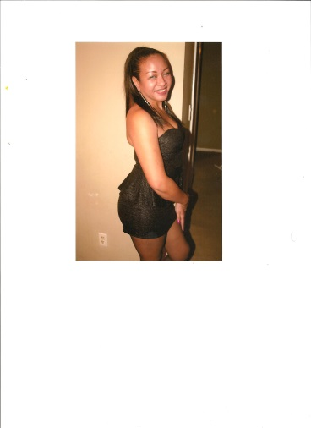

**Leila V. Gross**

**Contact # 910-261-6863**

**Email Address: leila.gross.sts@gmail.com**

**COMMERCIAL SPOT:**

**First Source Party Rental**

**FILM CREDITS:**

**Halloween Kills (Scheduled release date in fall 2020)**

**Featured background player**

**Laurie Strode’s ER Nurse**

**Uncle Frank (Working title; currently in post-production)**

**Featured Role**

**Port City Pirates (Independent student film)**

**Directed By Othello York**

**True Vision Entertainment, LLC 2012**

**Featured background player- Forensics Investigator**

**TELEVISION APPEARANCES:**

**The Righteous Gemstones (HBO)**

**Pilot Episode**

**Background Player**

**Secrets and Lies (ABC Studios)**

**Background Player**

**Prison Visitor**

**It’s Supernatural (TBN)**

**Dutch Sheets Episode**

**Featured Background Player**

**Girl at Bar**

**Under The Dome (CBS Studios)**

**Season 1 Finale and Seasons 2 and 3**

**Background Player**

**Town Folk**

**Homeland (Showtime)**

**Episode 4, Season 3**

**Background Player**

**Girl in car, girl talking on phone**

**The Tyra Banks Show**

**“True Confessions of the Male Mind” Episode**

**Aired April 16, 2008**

**EDUCATION**

**Fayetteville Technical Community College**

**Fayetteville, North Carolina**

**Drama 135- Acting for the Camera/Theater**

**Dennis Johnson- Professor**

**Associate’s Degree in Arts**

**Graduated 2017**