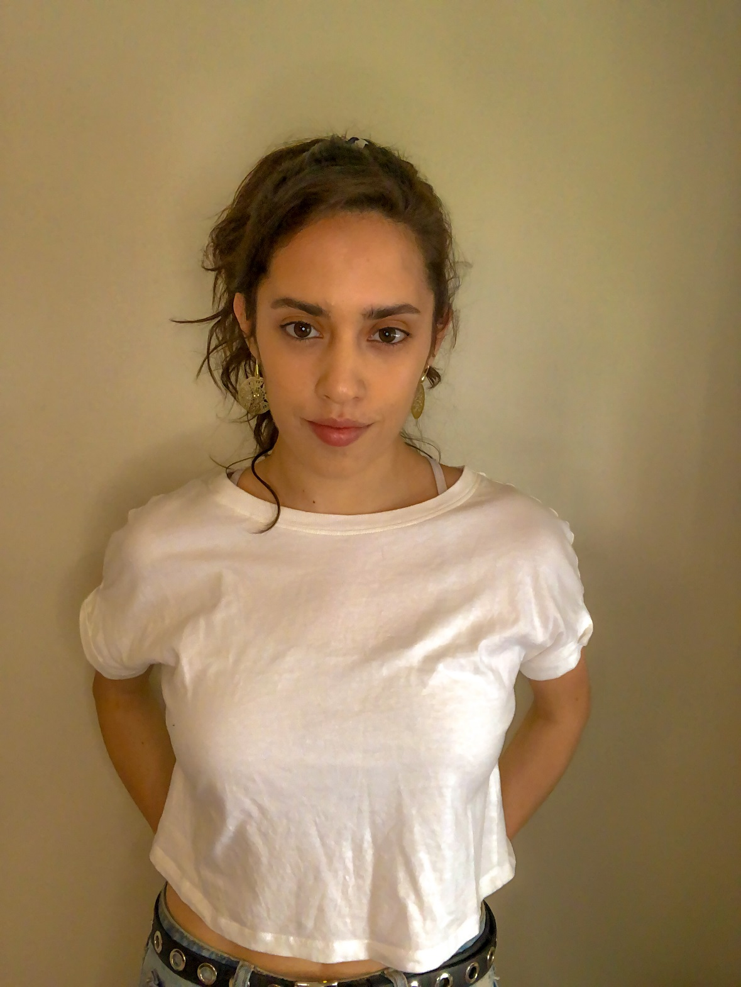

ANTONIA VEGA TORRES
ACTRESS
antoniavegatorres@gmail.com

EDUCATION

2013

Singing, acting and dance course, Maiten Montenegro Studio.

2017

Dance classes, Centro cultural Palo Seco.

2018

Introduction into acting, Pontificia Universidad Católica de Chile.

Pre-university course of Drama at Universidad Finis Terrae.

2019- present

Undergraduate Theatre student at Universidad Finis Terrae

2020

Urban dance classes, Academia Power Peralta.

2021

Musical Theatre course at Estemu Musical theatre School.

2021

Musical Theatre course, Municipalidad de Las Condes de Santiago de Chile

EXPERIENCE
Theatre
Musical “La tierra prometida”

Musical “En la luna”

Éxodo negro carnaval

Audiovisual
Short Film “Coven”

Comercial “Elijo reciclar”

Skills
Painting
Singing
Dancing
Rolling skating

Assemble

Lolalisa

Citizen

Michaela

Rol protagónico

Director/Producer

Teatro Finis Terrae

Elvira López

Alvaro López

Rodrigo Jauregui

H Films
Alejandro Harriet

