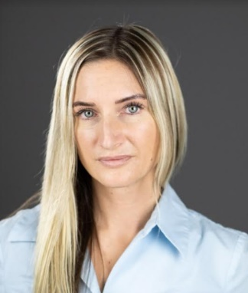

Leah Christine Stewart

(236) 788-6986  
[leahste@hotmail.com](mailto:leahste@hotmail.com)  
  
Height: 5’4”  
Weight: 110  
Hair: Brown with Blonde Highlights Eyes: Blue City: Vancouver

**Film and TV** Stumptown TVs Dir: Jason Richmond

**ley’s Pub (TVC)** Lead (Pub Patron) CFJC TV/Kamloops

**Theatre**Oliver Twist (Musical) Jack Peace Arch Performing Arts Academy

**Training**

**Director Workshop** Audition Techniques **Dir: Peter Deluse**

**Personal Acting Coach** Auditions, Blocking, Eye-Lines **Tr: Julianne Christie**

**Director Workshop** Script Reads **Dr: Christie Will Wolf**

**Intermediate Advanced Auditions** 8-week Program **Tr: Catherine Lough Haggquist**

**Casting Director Workshop** Casting Techniques **Cd: Candice Elzinga**

**Casting director Workshop** Casting Techniques **Cd: Kris Wozensensky**

**Director Workshop** The Hallmark Series **Dr: Peter Deluse**

**Intermediate Scene study** 8 week text Analysis program **Tr:Kelly-Ruth Mercier**

**Masterclass theatre** 3 years intense Tr: William Scott Wheeler

**Certificates/Additional Experience, UBCP Apprentice #33763, Nursing-Norquest BSc in Health Sciences Red Cross levels 1,2,3, Theater study with Peace Ach Performing Arts (Scott Wheeler) , Played Drum set for international Jazz fest in Toronto, classical and country singer**

**OVER 150+ days on set experience and over 200+ days on stage set experience**