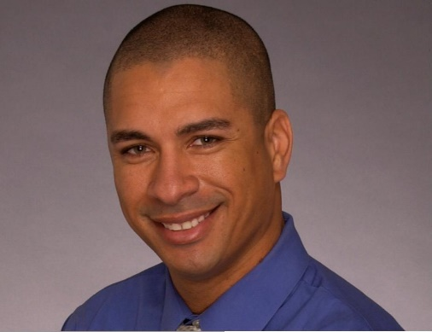Byron Browne

2831 S.83rd Dr. Tolleson AZ 85353

310-651-0822

Byronbrowne29@gmail.com

# Objective

Loyal bartender/mixologist for 17 years, looking to build regulars to come back for amazing service years to come by using policies and procedures. Driven by upselling food an beverage and retail sales.

# Experience

Saddle Ranch Chop House

**2011 – present**

Bartender / Shift Lead Mgr.

High volume due to events and location next to Gila River Arena and University of Phoenix Stadium

Retail/souvenir sales record holder: Sold 100k of store merchandise and memorabilia in 7 years

Events and Games sales average 3k

8400k in sales for final four basketball event by myself

5400k in sales with 458 dollars in retail sales on a normal night

Service bar and full main bar solo

Floor manager, food expo, shift lead, taking reservation answering telephone

Tapping and untapping beer kegs

Trained on Aloha system

* McCormick and Schmick’s Seafood Restaurant

2002 – 2011

Bartender

Knowledge of single malts, wine pairing, beer, and handcrafted drinks from scratch

Knowledge on species of fish, oysters, shell fish, free pour with bottles

Trained on Squirrel Systems

* Aramark and Levi Restaurants

2003-2011

Bartender

High volume, Special events, concerts, sporting venues

Counting cups for inventory

Use of a jigger

Cash drawers and Visa machines

* The Bear Chest in Wisconsin

Barback

* Milwaukee Brewers Professional Baseball Club

1991 -2000

Starting Pitcher

Minor and Major League (1 out of 750 ballplayers in the world)

Perform under any condition, rain or shine.

* Los Angeles Dodgers Professional Baseball Club

2001

Pitcher

Retired

* Federal Express

2000-2003

Courier/Driver of all truck classes

Promotion due to getting companies to switch over to federal express from rival companies

Time management, parcel delivery, loading and unloading packages

* Screen Actors Guild

2000 – present

Actor in various television shows, commercials and movies

Spokesperson, on camera and off camera work

# Education

Central High School St. Joseph, MO. 3.23 GPA

Peoria High School

Grand Canyon Univ. Associates and Bachelor’s degrees in Psychology & Sociology

# Awards and Acknowledgements

Positive reviews on Yelp and other social media websites

Promoted to Manager

Vast amount of regular guests due to great service

MLB Baseball player and an Actor in Screen Actors Guild

High dinner bill average from upselling food and drinks.