Angela M. Connell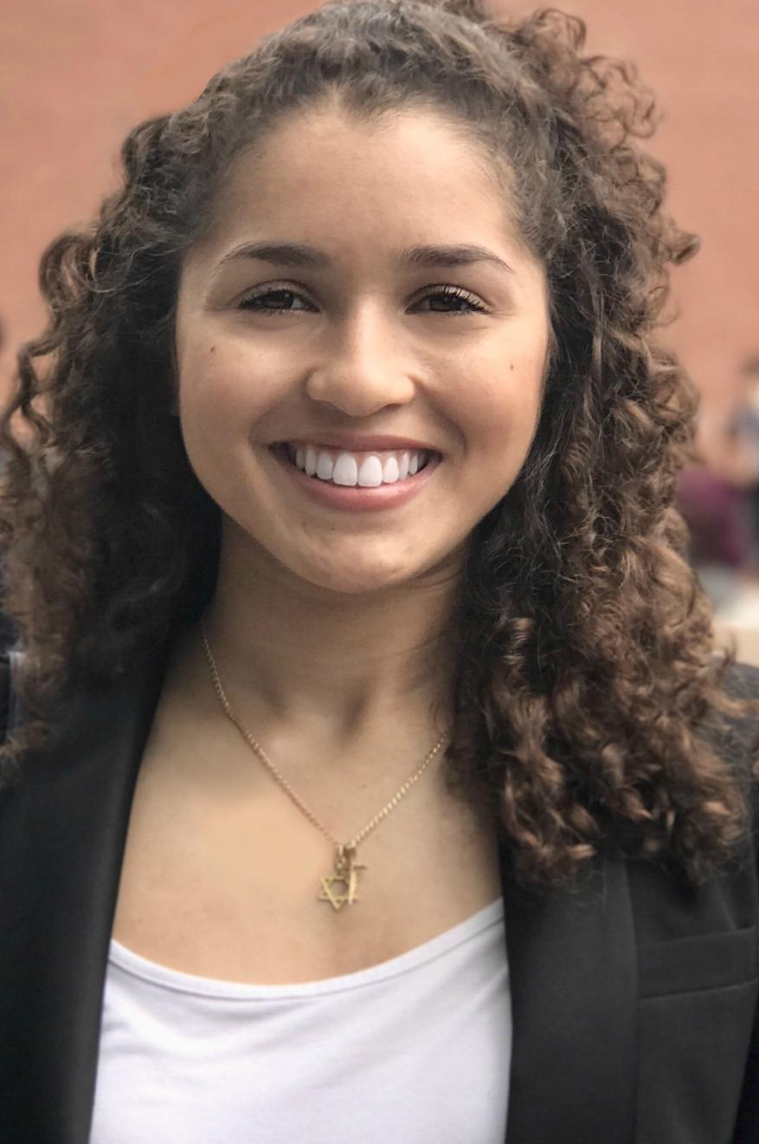

**CONTACT INFO Height -** 5’ 3”

**Email:** [ang](mailto:angie328@optonline.net)elamarieconnell@gmail.com **Age -** 22

**Phone**: (201) 966-06

**Website:** aconnellactor.com **Hair color -** Light Brown

**Eye color -** Light Brown

**EDUCATIONAL THEATRE**

Holiday Show Ensemble MHS Performing Arts Academy

Ths Phne 2.0 Myself MHS Performing Arts Academy

Studio Uncut: Lend Me A Tenor Maggie MHS Performing Arts Academy

Senior Directed One-Acts Shannon MHS Performing Arts Academy

**TRAINING**

MHS Performing Arts Academy

Acting - Beth Baur, Level 1, Intermediate

Dance for the Actor - Zakiya Atkinson, Intermediate

Dance - Amarily’s Dance Academy (2001-2004)

**SPECIAL SKILLS:**

Dialects: Conversational Spanish, Conversational French, Beginner German (dialects) Appalachian-Southern Accent, U.S. Southern Accent, Central London- British-English Accent Music: Plays the Trumpet, Reads Music, Can Conduct. Sports: Tennis, Bowling Art: Sketch artist: Media; pencil, pen, color pencil, acrylic, onyx, granite.