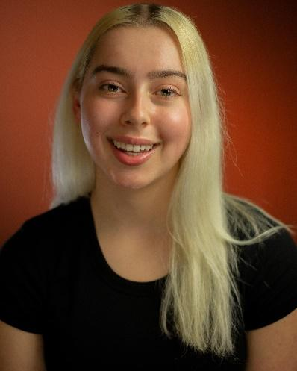
Amelia Mazurek
She/Her
Non-Union
Phone: + 44 7367881537
Email: amelia.mazurek6@gmail.com
Height: 170 CM Weight: 73 KG Eye Colour: Green Hair Colour: Blonde
Professional Training:
UAL Level 3 Performing & Production Arts, Acting
Advanced Acting Programme
Musical Theatre
Musical Theatre
Westminster Kingsway College
Performing Arts Studios
Stagecoach Stoke Newington
Stagecoach Southgate
Sharon McKevitt, Rob Alexander
Jimena Herrero
Micha Blue
Kate Diaz
Theatre:
“Drylands”
“Chaos” - Emily
“The Cherry Orchard” - Dunyasha
“Antigone” - Ismene
“Devised Refugee Project”
“TinselTown”
Tramshed Theatre
Westminster Kingsway College
Westminster Kingsway College
Westminster Kingsway College
Westminster Kingsway College
Ashmole Academy Theatre
Dir. Andre Pink
Dir. Holly Hawkes
Dir. Sharon McKevitt, Rob Alexander
Dir. Sharon McKevitt, Rob Alexander
Dir. Sharon McKevitt, Rob Alexander
Dir. Kate Diaz
“Show Girls”

Stoke Newington School
& Sixth Form
Dir. Micha Blue

“Greatest Showman”
Stoke Newington School & Sixth Form
Dir. Micha Blue
Voice Over:
“Twelfth Night”
Maria
Sharon McKevitt
Special Skills:
Language: Native English Speaker, Fluent in Polish Language. Sports: Swimming, Running, Bike Riding, Roller Skating, Ice Skating, Physically Flexible. Acting: Improvisation, Comedy, Shakespeare, Ensemble Work, Physical Theatre, Contemporary. Other: Loves Animals, Cooking, Baking, “Handy-Man.”

