

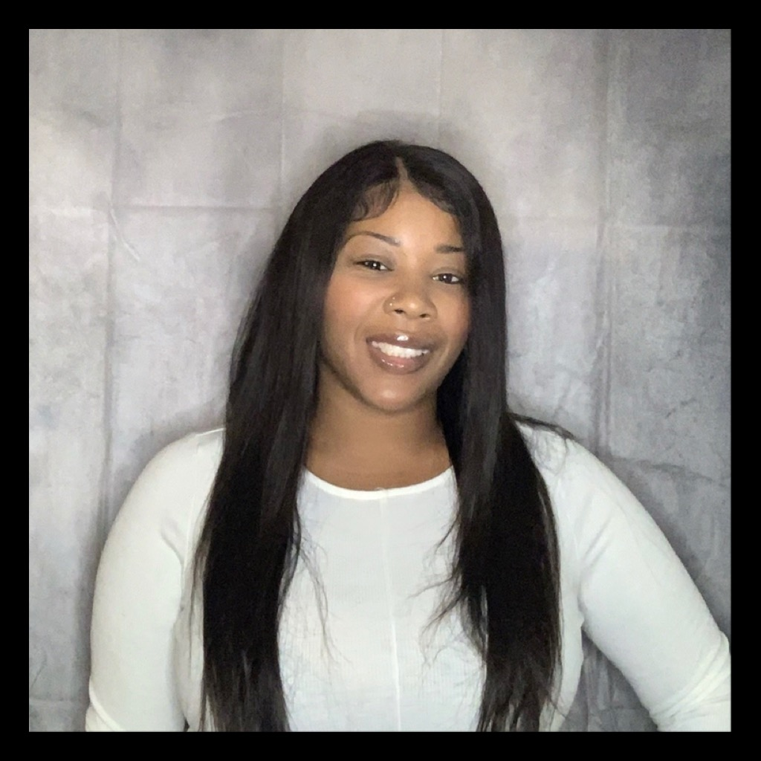

Shatasha R. Brown-Edwards

Model and Talent Management

Non-Union

Contact: 315-263-1384

Email: Shatashasb@gmail.com

**Physical Attributes :**

Height:5’3Hair:BlackEyes:BrownShoes:7 (W)

Bust:40DDWaist:33inchHips:45inchDress:10-12

* **Training:**
* John Casablanca Center

Acting

Monolouge Techniques, Commercial Techniques, Spokesperson Techniques, Cold Readings Techniques, Working with a Teleprompters, Improv Techniques, Voice Overs

Modeling

Posing with Props, Basic Runway, Technique, Runway Doubles, Runway Choreography, PhotoPosing

South-West Center

Urban Step Choreography, Drill, Reggae Dance, Hip-Hop Dance, Twerk Dancing, Cheerleading

Drama Class – Mrs. Thorton

**Special Skills:**

Sports- Basketball, Hockey, Track Running, volleyball

Dance - Urban Hip-hop(30yrs), Reggae dance (30yrs)

Music- Rap (10yrs),

Accents- Urban, Southern, New York, Valley Girl, Mature,

Certifications -Licensed Nurse, (6yrs), Nursing Assistant (12yrs), Drivers License (car 13yrs), Cpr/First Aid (15yrs)

Misc – Swimming, Cooking, Baking, Jump Rope (Single and Double), Skating,Good with children, Good with Animals (Dogs), Good with elderly, Fishing, hula hop, Painting,