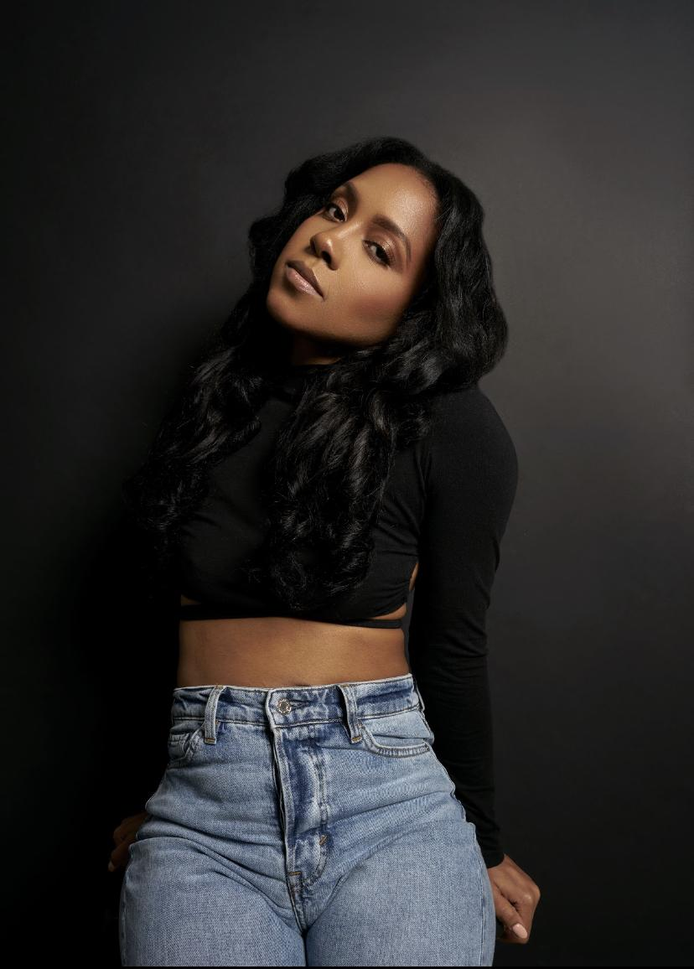 Shante’Flagg

*Aspiring Dancer, Model, Actress, Creative Director*

*Height: 5’4” Weight: 128Ibs*

*Email: shanteflagg1@gmail.com*

*Instgram: @_cherubimdance*

*Phone: (704) 890-7744*

*Residency: Charlotte, NC*

**Training**

| Shemeka Ann  Latasha Bryant  Mitchell Kelly  Gary Beauford | Beginner Heels, Foundation  Heel Talk Mastery, Heels foundation, Facials, performance, Mock Auditions, Mentorship program.  Foundation, Technique, Performance, leg strength  3day Intensive  Hip Hop, performance, personality, |  |
| --- | --- | --- |
|  |  |  |
|  |  |  |
|  |  |  |
|  |  |  |
|  |  |  |

|  |  |  |
| --- | --- | --- |
|  |  |  |
|  |  |  |
|  |  |  |
|  |  |  |
|  |  |  |
|  |  |  |
|  |  |  |
|  |  |  |
|  |  |  |

|  |  |  |
| --- | --- | --- |
| Exceptional dedication and Investment into my craft |  |  |
|  |  |  |
|  |  |  |
|  |  |  |
|  |  |  |
|  |  |  |

**Other Skills**

Coaching, Liturgical Dance, Great Listener, Great Work Ethic.