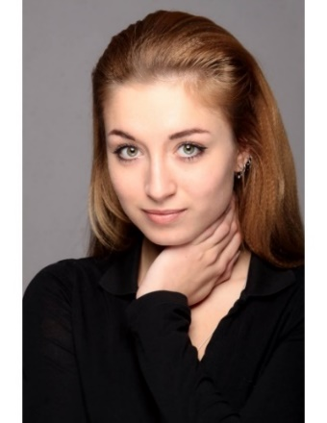

**IULIIA SMUSHKOVA**

Height: 175

Eyes: Green

Hair: Blond

Nationality: Ukraine

Email: [smushkova@ukr.net](mailto:smushkova@ukr.net) or [aka_fly@mail.ru](mailto:aka_fly@mail.ru)

Mobile phone: (323) 840-5306

Alias: Julia Smushkova

FB page: Julia Smushkova

Instagram: julia_smushkova

**EDUCATION:**

* Kyiv National I.K. Karpenko-Kary Theatre (Cinema and TV)
* Lee Strasberg Theatre and Film Institute (Summer Intensive Course)

**SPECIAL SKILLS:**

Actress, Dancer, Singer, Model, Drummer, Pianist, Bass Guitarist

**LANGUAGES:**

English (fluent), Russian (fluent), Ukrainian (fluent), German (minimal), Italian (minimal)

**EXPERIENCE:**

Theatre - National Theatre of Russian Drama of Lesya Ukrainka

Television

Film

**AWARDS:**

* Top 20 Actresses of Ukraine according to Glavcom.ua, 27th of May 2018
* “**The Best Young Actress” of the Classic Today Festival 2016** (Stage Production: Freeloader aka The Parasite)
* 3rd Place “International Vocal Competition” in Hungary [2007]
* “Miss Fantasy” [2004]
* “Audience Award” at “Talents of the World” 2004
* 1st Place “Mini Miss of Kiev [2005]
* “Grand Prix” Vocal nomination at the International Festival Bulgaria [2005]

**THEATRE**

|  |  |  |  |  |  |  |
| --- | --- | --- | --- | --- | --- | --- |
| **Year** | **Name of Show** | **Title Role** | **Leading / Supporting Role** | | **Distinguished**  **Directors** | |
|  |  |  |  | |  | |
| 2018 | “The Curious Incident of the Dog in the Night-Time” | Woman in the Train/on the Street | | Supporting | | Kirill Kashilhov |
| 2017 | “An Enemy of the People” | Petra | | Supporting | | Jonas Vaitkus |
| 2016 | “Two on the Seesaw” | Gittel | | Leading | | Alla Rybikova |
| 2016 | “The View From the Bridge” | Kate | | Leading | | Kirill Kashilhov |
| 2015 | “Love Madness” | Singer / Dancer | | Supporting | | Michail Reznikovich |
| 2015 | “Black Widows” | Widow 2 | | Leading | | Alla Rybikova |
| 2015 | “The Woman From the Former Times” | Tina | | Supporting | | Alla Rybikova |
| 2014 | “Alone Everywhere” | Malania | | Supporting | | Michail Reznikovich |
| 2014 | “Romeo and Juliette” | Dancer | | Supporting | | Kirill Kashilhov |
| 2014 | “We Need a Liar!” | Cabaret Dancer | | Supporting | | Oleg Nikitin |
| 2014 | “Spring Awakening” | Thea | | Supporting | | Katzin Kazubko |
| 2014 | “Norway Today” | Julia | | Leading | | Alla Rybikova |
| 2013 | “Freeloader” aka “The Parasite” | Olga Elezkaya | | Leading | | Michail Reznikovich |
| 2012 | “The Crazy Blood” aka “The Wild Blood” | Latifa | | Leading | | Alla Rybikova |
| 2011 | “The Deal of Honour” | Ully | | Supporting | | Dmitriy Morozov |
|  |  |  | |  | |  |
|  | **FILMOGRAPHY** |  |  | |  | |
| **Year** | **Title of Film** | **Title Role** | **Leading / Supporting Role** | | **Distinguished**  **Directors** | |
| 2015 | “Life on the Edge” | The Best Friend | | Supporting | | Evgeny Doronin |
| 2013 | “The Thing That Kills Me, It’s” | The Horror Reflection | | Supporting | | Boris Piskunov |