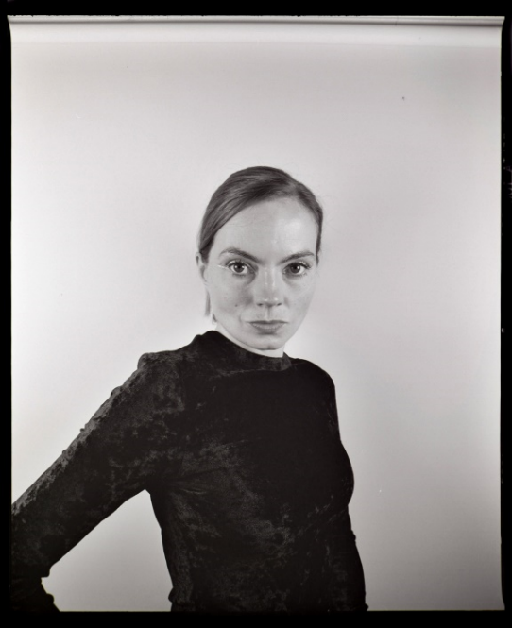
Height: 5ft5
Dress Size: 8/10
Hair: Dark Blonde
Eyes: Brown
Build: Slim
Age: 35
Playing Age: 27-35
Location: Birmingham | London
Full Driving License
Enhanced DBS
Public Liability Insurance
Languages: English
Instruments: Clarinet (Grade 8)
Sports: Horse Riding | Running

TELEVISION

Stand-In incl. Reading In: DI Ray (ITV) Oct – Dec 2021 _ Gemma Whalen

Stand-In: Wool (Apple TV) Nov 2021 _ Geraldine James/ Various

Walk-on: Doctors (BBC One) Walk on (multiple) August 2016 – Present

Walk-on: Shakespeare and Hathaway (BBC One) Nov 2018

COMMERCIAL

Speaking Role: Internal Comms Brief (Royal Mail) Sept 2021

FILM

Stand-In/ Body Doubling: Fighting with my Family (Film 4) _ Lena Heady

PROMOTIONS

Gucci | Dior | Guerlain, Exclusive Brand Ambassador

MEDIA

Re. Future Collective _ Local and National News Pieces/ Social_ 2013 to present

