|  |
| --- |
|  |

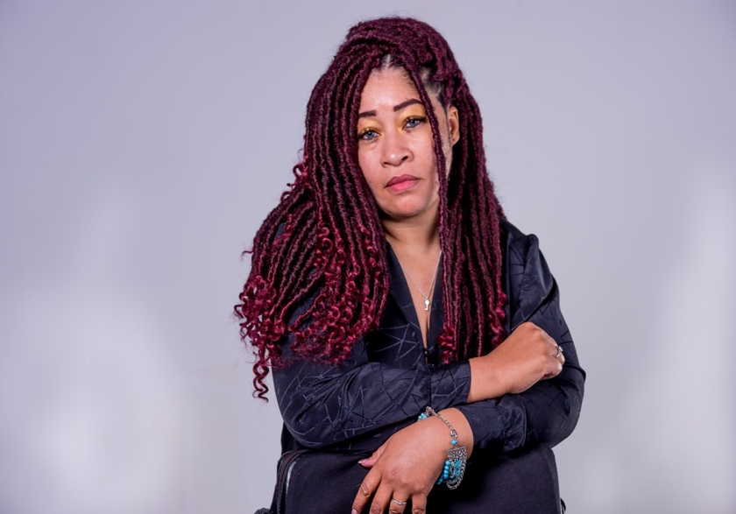**Dana Jones K. 901.550.1764** [**MzDanaK@outlook.com**](mailto:MzDanaK@outlook.com)

|  |
| --- |
| **Attributes** |

**Height: 5’3** **Hair: Dark Brown**

**Weight: 187** **Eye Color: Dark Brown**

|  |
| --- |
| **Training** |

**Women In Film and Television**

**Actors Track Workshop**  **Atlanta, Ga**

**Black Women in Film Network**

**Actors Summit**  **Atlanta, Ga**

**Pinch & Ouch Theater**

**Miesner Technique**  **Atlanta, Ga**

**Rule the set**

**P.A Workshop**

**Atlanta, Ga**

**Celebrity Central**

**Isa Totah:**  **Online Scene Study, Monologues & Cold Readings**  **Los Angeles, Ca**

**Inclusive Arts Masterclass**

**Elizabeth Labbe-Webb: Scene Study, The Foundation- Acting 101 Atlanta, Ga**

|  |
| --- |
| **Skills** |

**Fashion Merchandising, Speech, Accent- Southern, Marketing, Drive, Fashion Innovator, Write Lyrics, Talent Scout, Presentations, Power Points, Draw, Model, Take Orders, Plan, Fashion Show Coordinate, Public Speaking, Advocate, Short Hand, Poetry, Scheduler, Computers, Problem Solve, Server**

|  |
| --- |
| **Message: See Us Diffrently & Unite** |