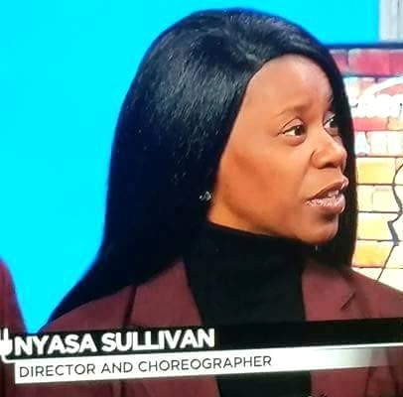

Gender: Female
DOB: 1970
Age Range: 30 - 70 (51)
Ethnicticity: African American
Height: 5"3
Weight: 130
Build: Athletic
Hair: Black
Eyes: Dark Brown
Chest: 36
Waist: 30
Hip: 38
Shoe: 7 1/2




Ms. Sullivan is no stranger to the world of the arts. Being the principle female dancer for over 30 years of Barbara Sullivan’s Atlanta Dance Theatre Inc., the first African American dance company in the southern region, she has explored many fields of the arts as an actress, writer, director, and choreographer, but she is best known as a dancer and instructor.
She started taking classes at the age of three and has been teaching since the age of fourteen. Starting in her mother’s dance studio moving forward to teach in many of the city’s top private school, early learning centers, and Christian academies throughout the area. She believes in giving back to the community by teaching the art of dance to those who have never had the spiritual experience of it.
Throughout her years in the arts, she has appeared in many stage and film productions, as well as performed with many singing artists for stage and video. Ms. Sullivan now dedicates her life and her talents to God. She has over five different dance companies ranging from age 3 to adult. Since her start she has become the successor of The Barbara Sullivan Dance Theatre as well as DanceGospelDance Inc. She is a member of Word of Faith Christian Ministries under Dr. Dale C. Bronner and a longtime member of The Sanctuary Dancers which is one of many companies she directs. She gives all honor, praise and glory to God who is the head of her life for shaping her to be who she is and who’s she is today. “For in him I live, breath, and move.”

Training
Barbara Sullivan’s Atlanta Dance Theatre 1973 – Pres.
ValJeanne Grigsby’s Dance Studio 1973 – 1988
Patdro Harris Total Dance Theatre 1988
Arthur Mitchell Dance Theatre of Harlem (Summer Conference) 1988
Sara Yarborough The Alvin Ailey Dance Company (Summer Conference) 1987
Chuck Davis African Dance Company (Summer Conference) 1987
Frank Hatchett Dance Company (Summer Conference) 1987
Stanley Zimpakolos Northside School of the Performing Arts 1984 – 1988
Gary Harrison Northside School of the Performing Arts 1984 – 1988
Special Skills
Dancer
Actress
Model
Singer
Choreographer
Director
Instructor
Writer
Costume Mistress
Rehearsal Mistress
Administrative Director
Artistic Director
Prop Manager
Stage Manager
Seamstress
De’ Jimba Drummer
Teaching / Instructor
Barbara Sullivan’s Atlanta Dance Theatre 1984 – Pres.
Fulton County Arts Program 1988 – 2015.
Cobb County Arts Program 1988- 2015.
DeKalb County Arts Program 1988 – 2015.
Gwinnett County Schools 2015 - 2020
Seeds of Faith Christian Academy 1995- 1996
Seeds of Greatness Christian Academy 1995 -1997
Harvest Rain Church 1998 – 2008
St. Timothy United Methodist School 1998 – 2015
North Decatur United Methodist Church 1998 - 2006
Victory Baptist Church 1988 – 2015
Hopewell Christian Academy & Early Learning Center 1998 – 2015
Mt. Nebo Christian Academy & Early Learning Center 1998 - 2008
Audience Inc. 1988 - 2008
North Metro Academy of Performing Arts 2014 - 2020
Young Audiences 1990 - 2010

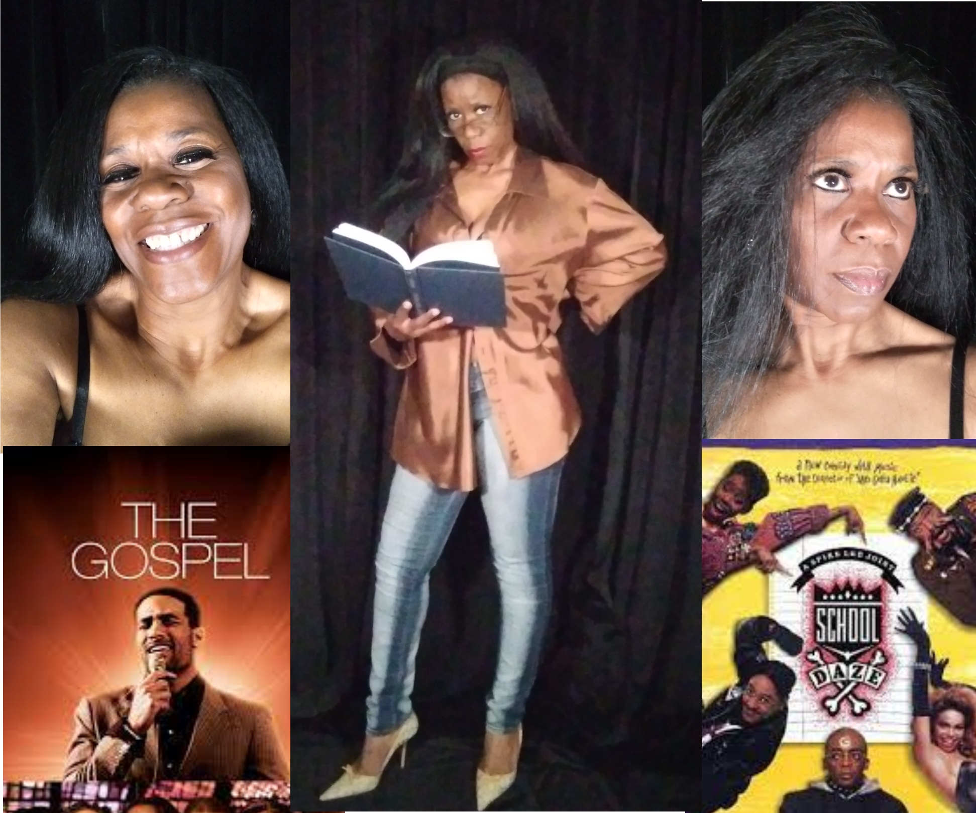

Stage and Theatre
Barbara Sullivan’s Atlanta Dance Theatre
Northside School of the Performing Arts European Tour
Arrested Development (Original Member)
Coca Cola Olympic City (2000 Olympics)
The Sanctuary Dancers
Gary Atkins “Holler” Tour
The African Dance Connection (Young Audience Inc.)
Let’s Have Church
The Wiz
Queens of the Nile
The True Story of Christ
The Crucifixion
National Black Arts Festival Tour
Sweet Auburn Festival
The Second Coming of Christ
The M. L. King Festival Tour
The Amen Corner
The Maafa Suite (2001)
The Black Nativity (1982 - 1990)
Macbeth
A Raisin in the Sun
A Chorus Line
She shall be called Woman
Coca Cola Universal Tour
The King of Glory (1992 - 2010)
You’re a Good Man Charlie Brown
Universal Soul Circus
P. T. Barnum
Pippin
Cry Freedom

Film and Video
Three Grand Music Video
Trouble Two Music Video
CrisCros Music Video
TLC Music Video
Tribe called Quest Music Video
A day in the life of Arrested Development

Television
Time Out / Fox 5
Sabena Airlines Commercial
Coca Cola Commercial
A Murder in Mississippi
In the Heat of the Night
Savannah

Feature Films
Fled
Trespass
Remember the Titians
School Daze
The Gospel "The Movie"

Director / Co- Director / Writer
The Journey (Writer)
The Crucifixion
Mor2Men (Writer)
Willy Wonka (Director)
School House Rock Jr. (Director)
Oz Jr. (Co-Director)
Lion King Jr. (Co- Director)
Peter Pan Jr. (Co- Director)
Flakes (Director)

