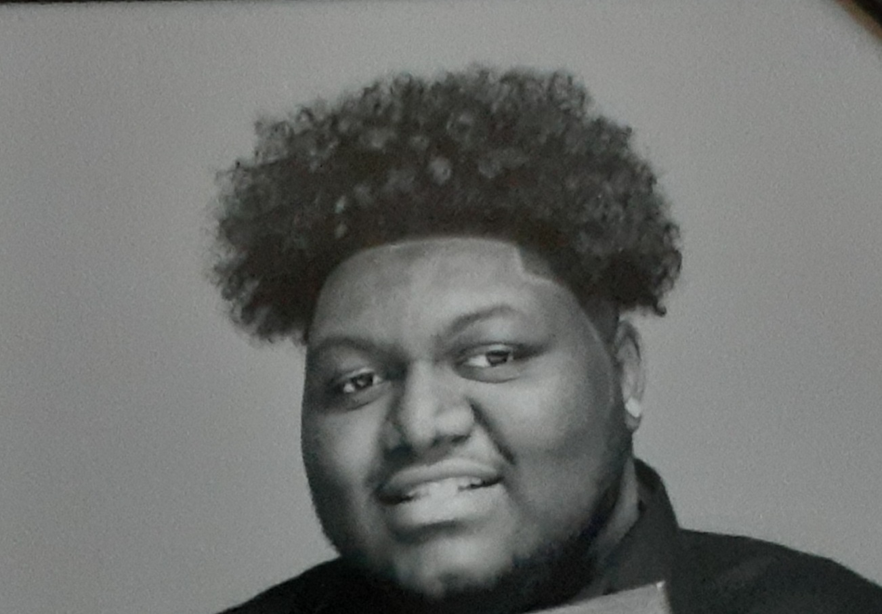

THEATRE
PLAY TITLE Theater Company Director

Sister Act JR. Duluth High School Ms. Carla
Act Like a Man Stanford Theater Ester Miles
Birth the Musical Marked Squared Atlanta Carlotta Washington

TELEVISION (Extra)
SHOW TITLE Network Producer

Survivors Remorse S.4 Starz Extra
Being Mary Jane S.4 BET Extra
Risky Brigade Lead role

COMMERCIAL
PRODUCT/ BRAND Production Company

Quiznos Fulton Films 2008 Commercial

EDUCATION

2022 Duluth High School Graduate

Drama Kids International -2015
Imaginative Learning Skills /Developmental Skills/Comprehensive Skills

Special Skills:
Voice/ Speech, singing (tenor) Theatrical, Camera acting Playwright acting, Pantomime acting, auditioning skills.

