John Anthony
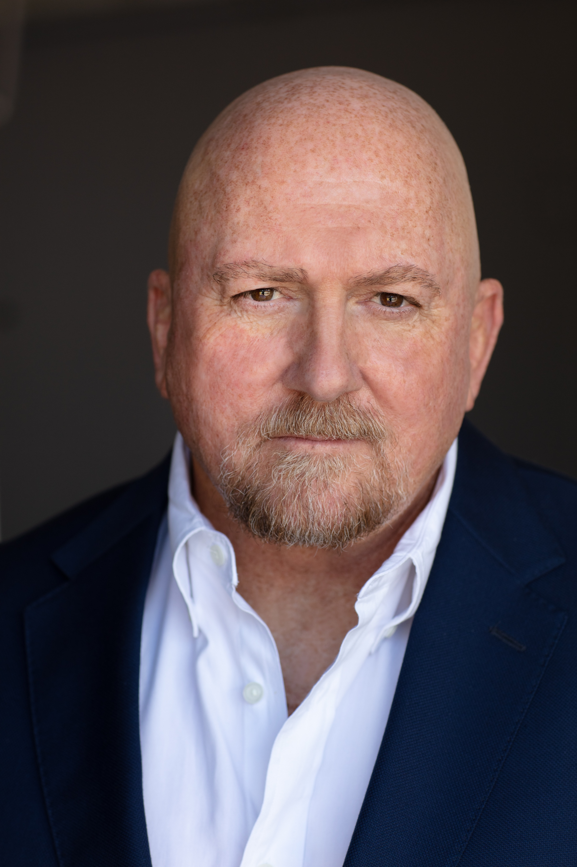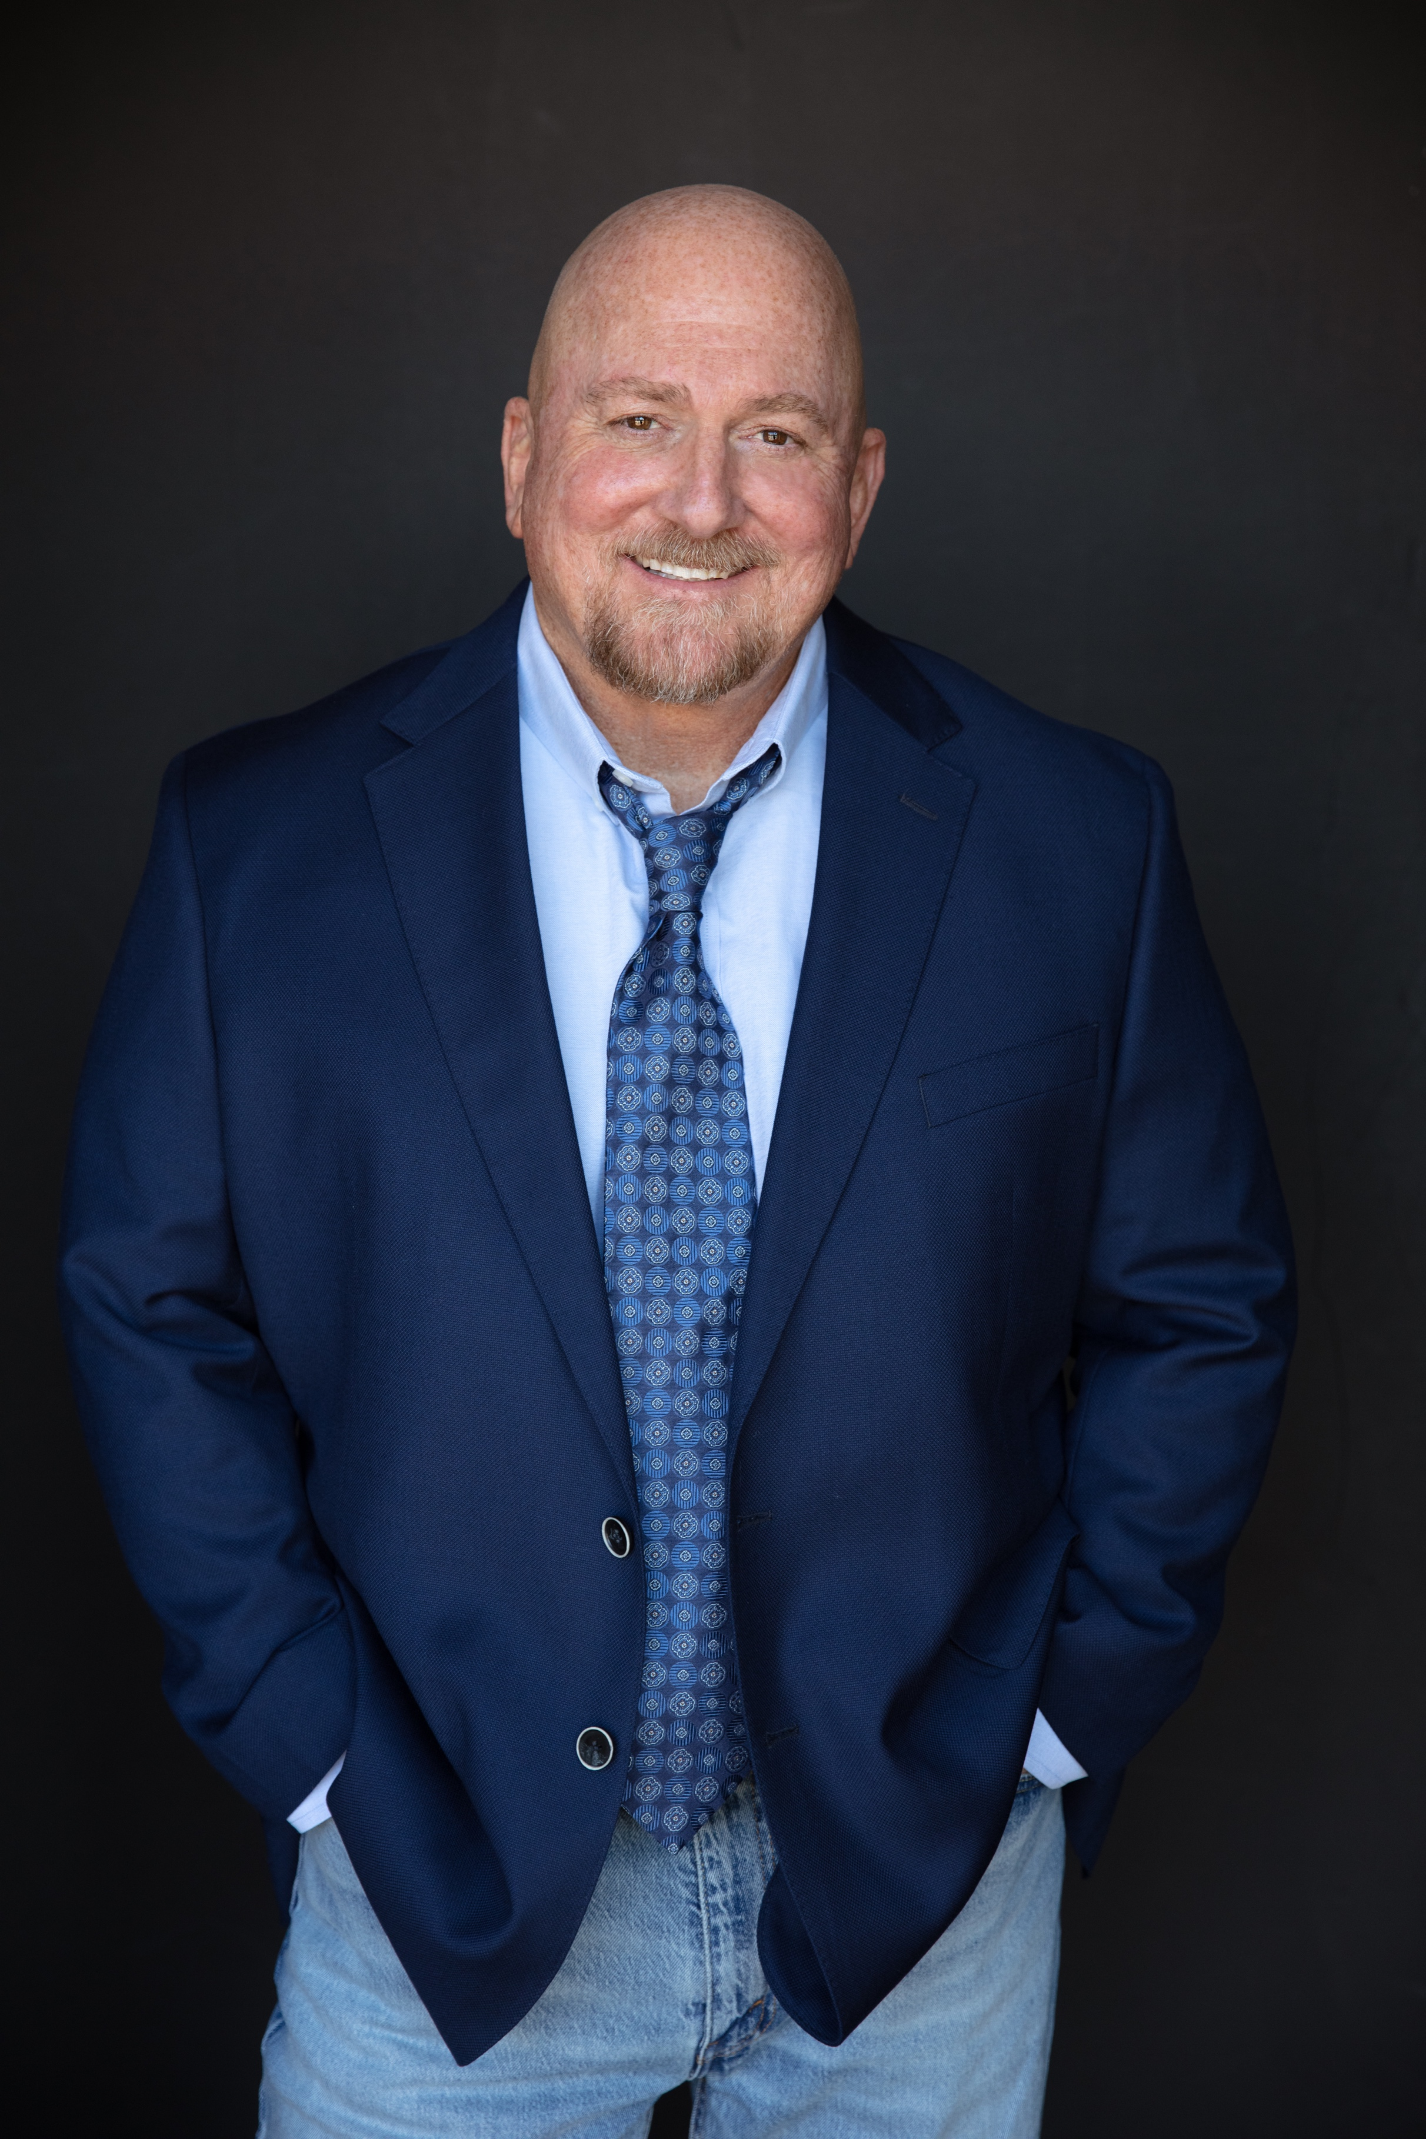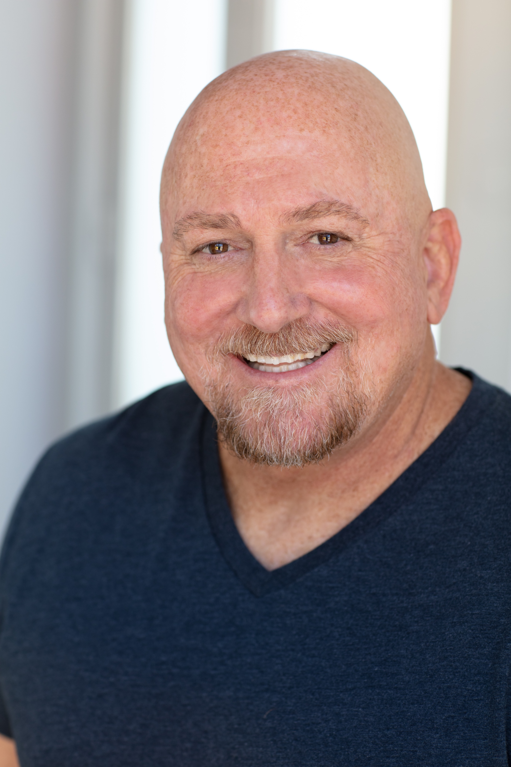

Height: 5’9
Weight: 220
Body Type: Athletic

Film: Role: Director:
A Love Not Lost Lead John Anthony
My Favorite Song Lead John Anthony
A Family Matter Lead John Anthony
A Date for Dad Supporting John Anthony
Rookies Lead John Anthony
Swimmers Lead John Anthony
Legacy Supporting Ben Ward
Rounds Lead John Anthony
Book Closer Supporting Edgar Paul
Gold in the Man Lead Olivia Sabini
The Session Lead DW Studios, Jae Dyer
Estranged Supporting Phylicia Lindsey
A Gift Lead Eric Hanson
Bomb City Featured / Courtroom Jameson Brooks
Rough Luck Supporting Harrison Gray
The Face of Accomplishment Supporting Calvin Herbst
Early Onset Featured Taylor Worst

Television: Role: Director:
Price of Fame Supporting Brad Osborne /AMS
Reagan: from Movie Star to President Featured / Secret Service Brad Osborne /AMS
The Network Supporting Chason Laing / DEO. TV

Theatre / Live Performance: Role: Director:
Winner Supporting Everett Hoffman
Comedy Sportz Improv Troupe Lead Rob Haddon

Commercials:
(List available upon request)

Training:
Extra Mile Acting Workshop Glenn Morshower Dallas,Texas
REACT : Actors Studio Michelle Condrey Dallas, Texas
Casting Workshop Jackie Burch New Orleans, LA
Improv for TV and Film Wendy Pennington Dallas, Texas

Special Skills:
Sports: Basketball, Baseball, Tennis, Golf, Football, Bicycling, Swimming, Professional Wrestling, Running, Weight Lifting, Rollerblading, Motorcycle Riding, Dancing: (Swing, Texas Two Step, Country) Cooking.

