Personal Information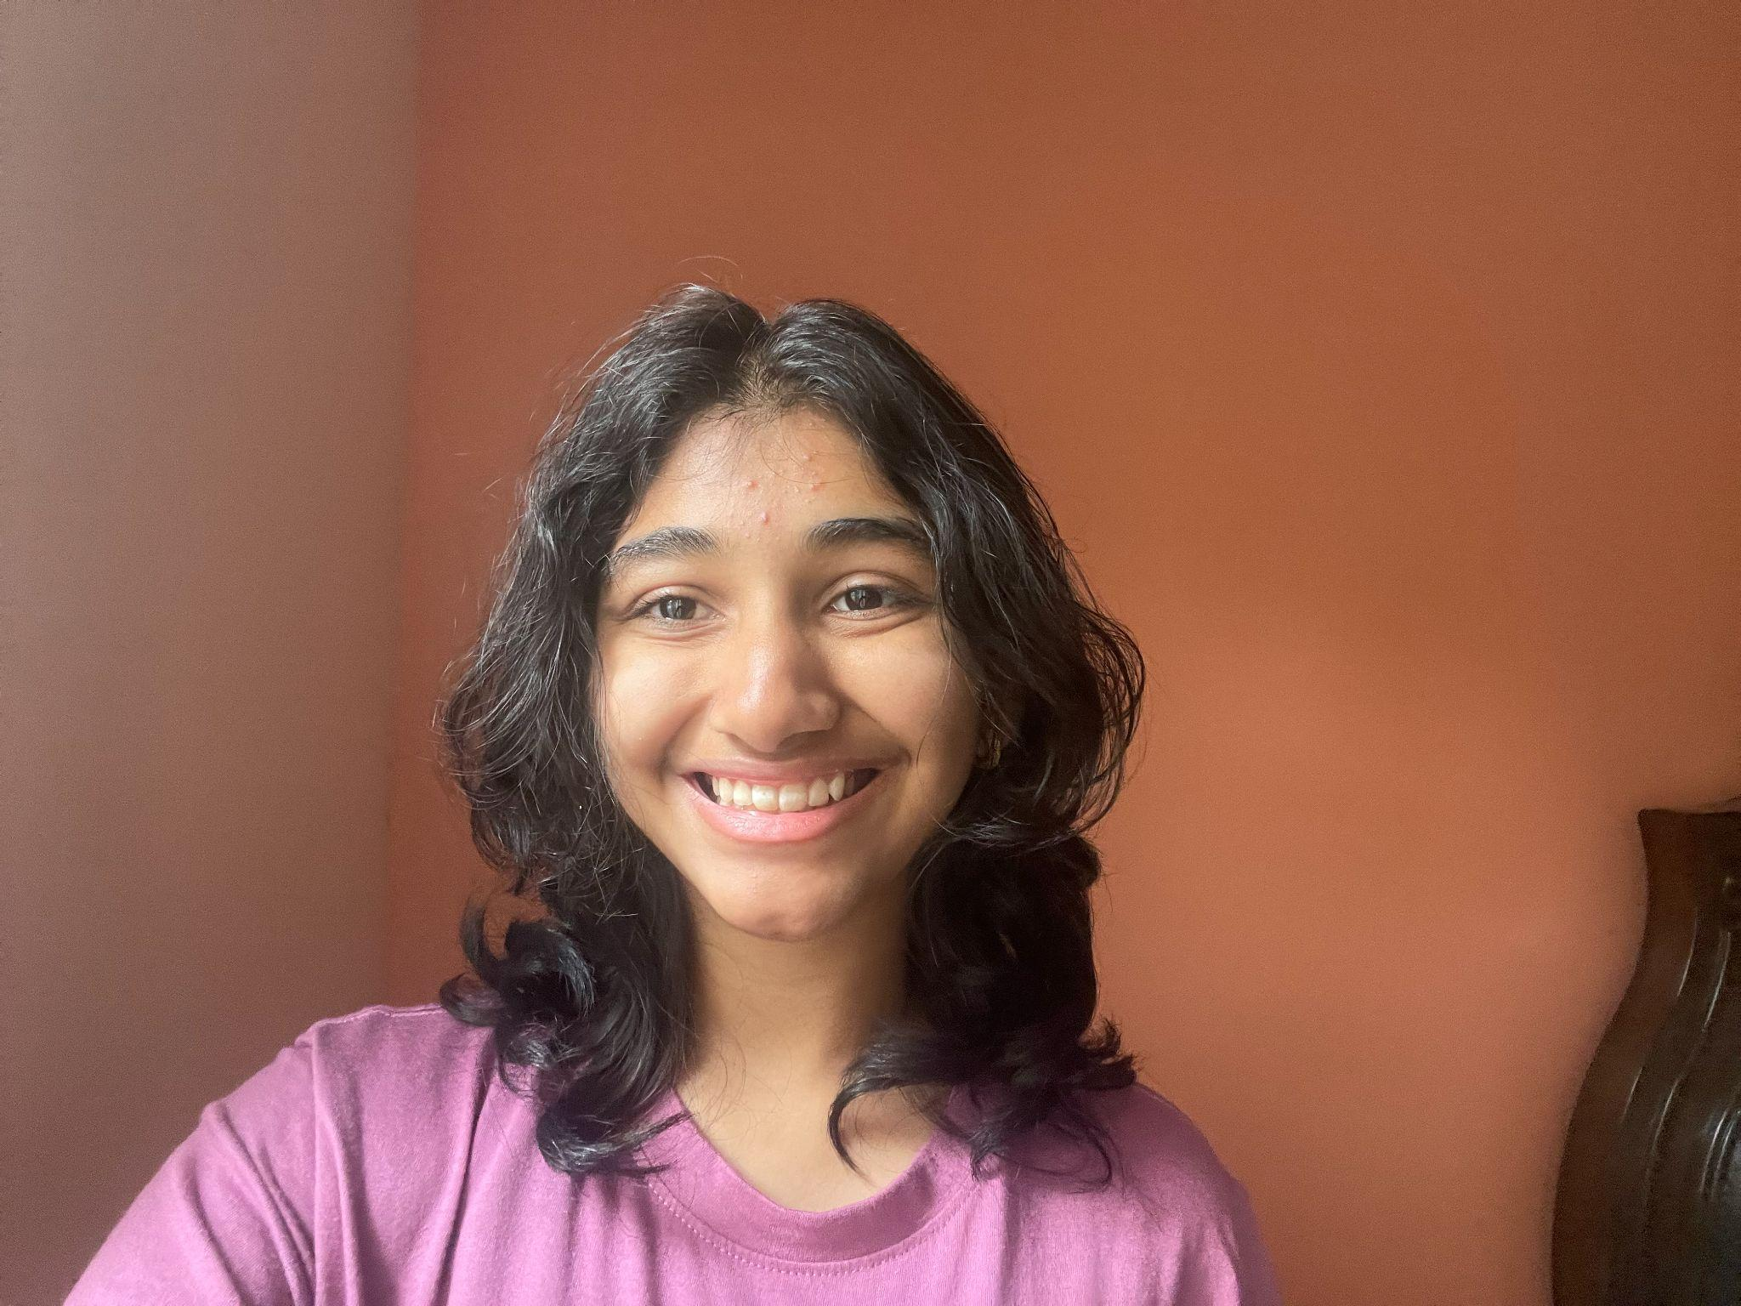

(Non-Union)

904-775-0705

email@domain.com

Height: 5’ 4” (164.6 cm)

Weight: 107Ibs (48.5kg)

Eye Color: Brown

Hair Color: Black

____________________________________________________________________________________

**THEATER**

*N/A*

____________________________________________________________________________________

**FILM/TV**

*N/A*

____________________________________________________________________________________

**EDUCATION & TRAINING**

Voice: N/A

Dance: JAXICS Diwali program for five years.

____________________________________________________________________________________

**SPECIAL SKILLS**

Able to speak some Hindi.

Commercial Resume available on request.