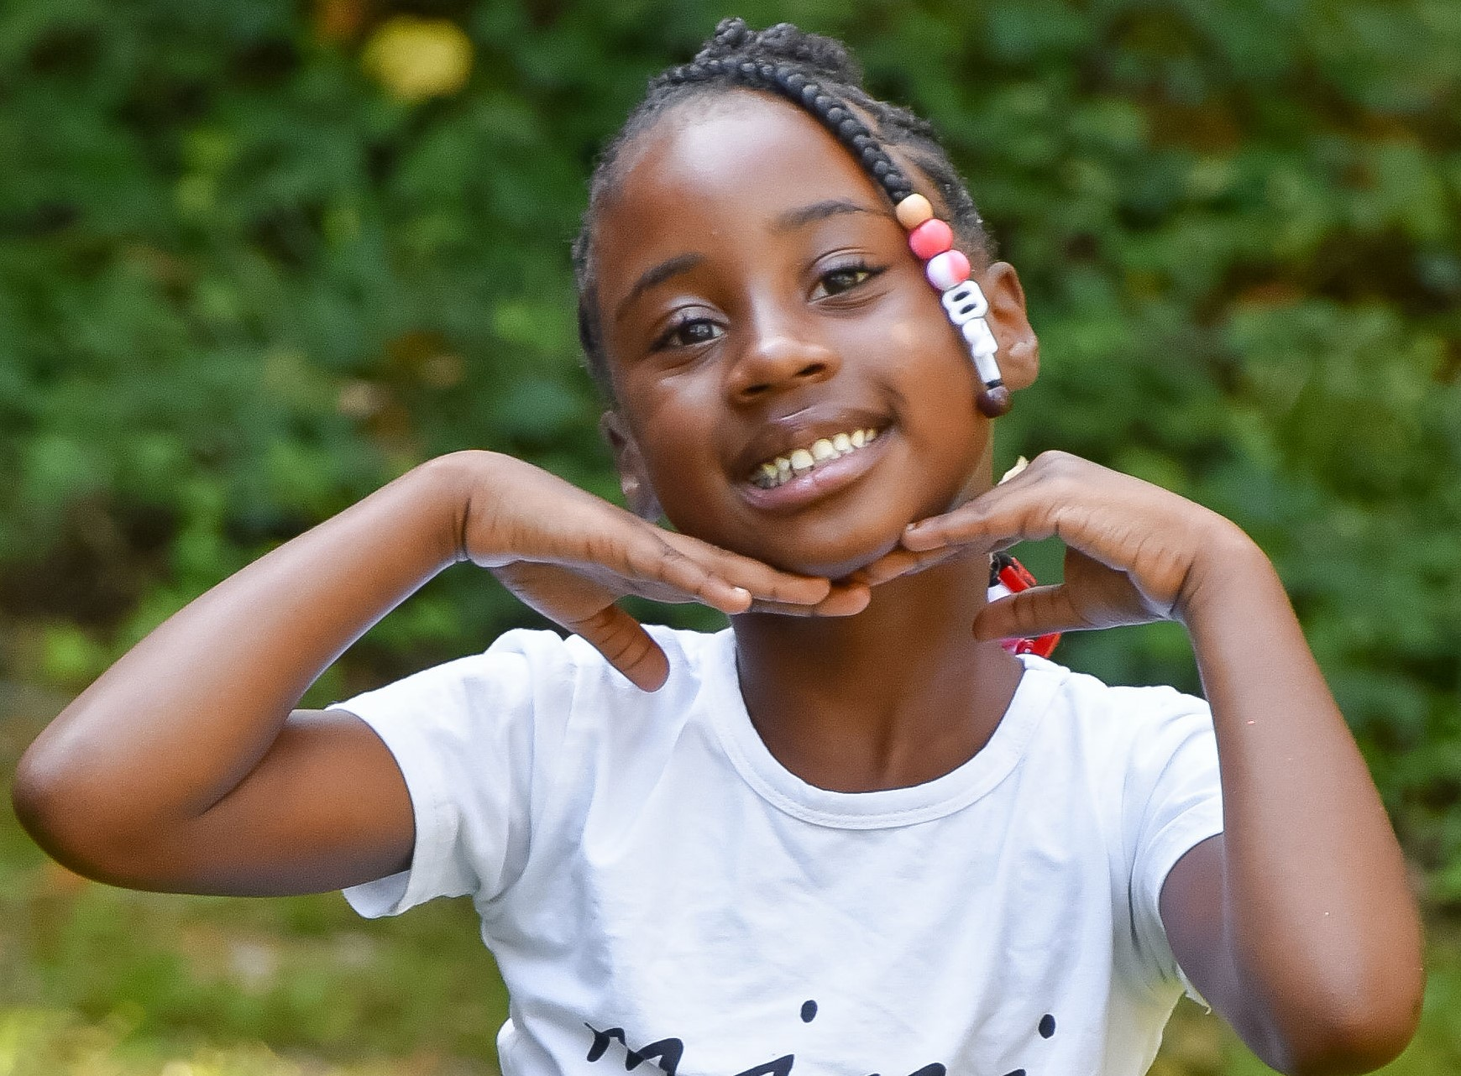 |  | EDUCATION
August 2020- Present
David Perdue Primary

Brianna Cosby  I am passionate about my work and open to performing in every type of television, cinema, commercials, and other projects.  Profile  Height – 47.50 IN  Weight - 52 lb  Race- African American  Hair Color- Black  Eyes- Brown  Shoe size- 1.5  CONTACT  PHONE:  (478) -542-3872  EMAIL:  Katrina.rouse31@gmail.com |  | WORK EXPERIENCE
Model (Part-Time)
- Brand Ambassador for Baby Girl Magic Boutique
- Featured in multiple advertising campaigns increasing leads.
- Printed in magazines for select brands.
- Model for Hutchinson Photography
- From experience, I have a better understanding of poses and communication with the photographer.

 |  | SKILLS
Sports: Registered AAU Track & Field Runner
Special Skills: Dance and a Roblox Gamer
Able to face the camera confidently.

