Joanie Olivia Adeshina
Personal details:
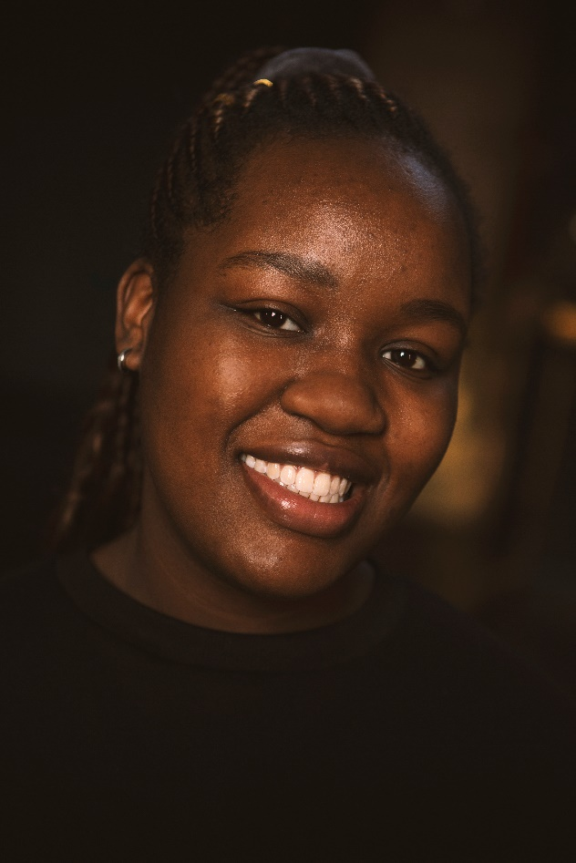
Phone number: 0894390399
Email: joaniedancemom@gmail.com
Age: 20 DOB (9/10/2001)
Height: 5’6 (167.64 cm)
Appearance: Female, Black African, Brown eyes, Black hair
Location: Cork Ireland
Voice quality:
School: ACTROVISION
Training:
- Acting for Camera 1-3 (2021-Present)
Completed in Actorsvision Cork Ireland
Theatre:
- Mr Green, lead, primary school, (2006)
- Oliver, Supporting, Chor Fheile
- Lion King, Supporting, Chor Fheile
- Peter Pan, Pantomime, dancer
- The wicked that was, Supporting, Secondary school (2017)
Skills:
- Accents (Cork, Dublin, Irish, Nigerian, London)
- Basic singer and dancer
- Ability to take direction

