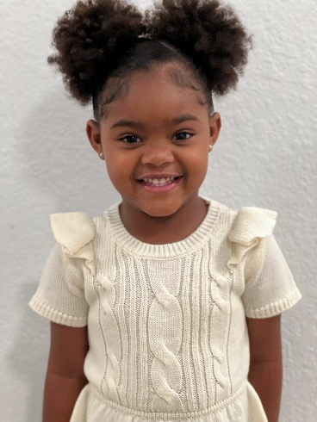

Nova Rodriguez
Lehigh Acres, FL
Phone: 414-243-8686
Email: burtonshautelle@gmail.com

Professional Summary:

Nova is a very energetic and flexible child model. Displays the ability to follow instructions and quickly adapt to any learning environment. She has a very playful attitude, talkative, outgoing, curious to learn new things and always keen to improvement. We would love the opportunity to work with your agency.

Measurements:

Height – 3 feet 5 inches
Weight – 30 lbs
Age – 3
DOB – 12/03/2018
Hair Color – Brown
Hair Length – Medium
Hair Texture – Curly
Eye Color – Brown
Dress Size – 3T/4T
Shoe Size – 8c
Pant Size – 4T
Shirt Size – 3T

Skills:

Interests – Swimming, Reading/Books, Dancing, Singing
Keen Listener
Super flexible and able to communicate well in English and Spanish
Beginner Sign Language

