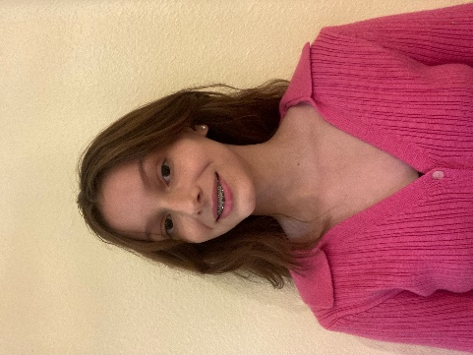
Contact: (321) 318-0537
Email: penniedavenport01@gmail.com

No current acting experience.
Pennie Davenport Non-Union

Physical Attributes: ………………………………………………………………………………………………………………………………………………………………………………………………………………………………………………………………………………………………………………………………………………………………………………………………………………………………………………………………………………………………………………………………………
Height: 5’3”
Weight: 101lbs
Eye Color: Brown
Hair Color: Brown
Characteristics: …………………………………………………………………………………………………………………………………………………………………………………………………………………………………………………………………………………………………………………………………………………………………… …………………………………………………………………………………………………………………………………………………………………………………………………………………………………………………………………………………………………………………………………………………………………… ………………………………………………………………………………………………………………………………………………………………………………………………………………………………………………………………………………………………………………………………………………………………………………………………………………………………………………………………………………………………………………………………………
Easy to work with, Outgoing, Adaptive, Flexible, Diligent, Great with Time management
Special Skills: ………………………………………………………………………………………………………………………………………………………………………………………………………………………………………………………………………………………………………………………………………………………………………………………………………………………………………………………………………………………………………………………………………
- Dance
- Improvisation
- Martial Arts
- Theater acts
- Communication
- Collaboration
- Teamwork

