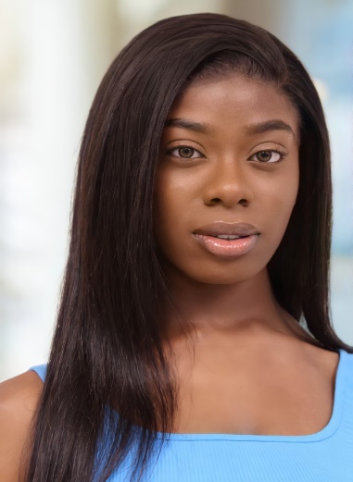Vanessa Bucknor

(Non-Union)

(678) 570-1126

vanessabucknor@icloud.com

Height: 5’ 9” (173 cm)

Weight: 152 lbs (69 kg)

Eye Color: Hazel Brown

Hair Color: Natural Black

___________________________________________________________________________________

**THEATER**

*Sweat* Cynthia Olubajo Sonubi

__________________________________________________________________________________

**FILM/TV**

*Colour* Lead Student Film at GSU

*Bad Vibes* Lead Student Film at GSU

____________________________________________________________________________________

**EDUCATION & TRAINING**

On Camera Commercial Acting Workshop Tom Logan Los Angeles

On Camera Television & Film Acting Tom Logan Los Angeles

Camera Blocking Tom Logan Los Angeles

Beginning Acting Lorraine Reyes Atlanta

Scene Study Susan G. Reid Atlanta

Advanced Acting Mary Emily Deal Atlanta

Georgia State University: Prospective B.A. in Film & Media, Minor in Spanish

___________________________________________________________________________________

**SPECIAL SKILLS**

Singing (Voice: Alto)

Dialect (British, Valley Girl, Southern)

Basketball

Hip-Hop Dancing

Runway Modeling

Makeup Artist

Runway Modeling

Varsity Tennis

Sketch Drawing

Swimming - General

Skating

Drivers License