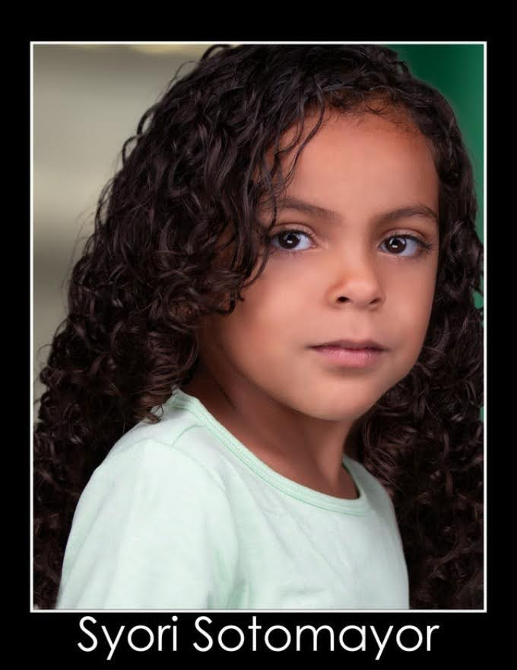

**Syori Sotomayor**

**Joscelyn4558@gmail.com**

**(773) 397-3584**

Height: 47in

Weight: 50lbs

Hair: Dark Brown (Curly)

Eyes: Dark Brown

Age: 7

**Experience:**

Macy’s Runway Walk Valencia Mall

Silent Night Angel Monument Ice Rink

Nutcracker Candy cane Monument Ice Rink

Sing 2 Ms. Crawly Academy of Children’s Theatre (ACT)

Tangled Elf Academy of Children’s Theatre (ACT)

JCPenney Runway Walk Valencia Mall

Where you going? Big Sister CGTV Showcase

**Training:**

Monologue Workshop Adrian R’Mante

Cold Reading Tanya Chisholm

Self-Tape Tips Adrian R’Mante

Improv Workshop Daniel Curtis Lee

Audition Technique Sophie Oda

Commercial Workshop Hutch Dano

Scene Study Workshop Adrian R’Mante

On-Camera Workshop CasianKolodjski

**Special Skills:**

Dancer, competitive figure skater, swimmer, animal lover, gymnastics, bike rider

**Languages:**

Spanish and English