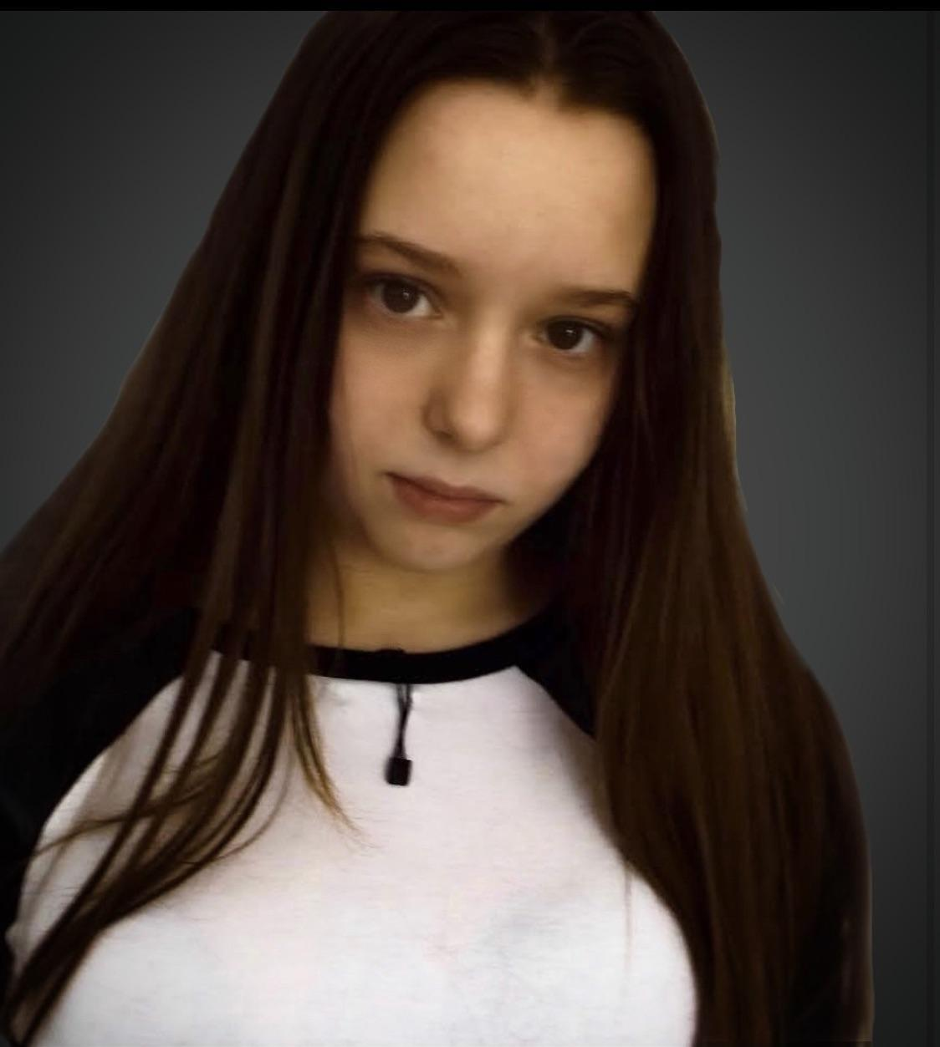

| **Gabriella Bonelli** non-union  **Contacts: (845) 399-3212**  **Email: Gabbybonelli721@gmail.com** |
| --- |

| **Physical Attributes:** |
| --- |

Height: 5’2

Weight: 98 pounds

Eye Color: Brown

Hair Color: Brown

Braces

| **Special skills:** |
| --- |

Dance , Singing vocal range :soprano,Running, basketball , gymnastics , filmmaking, video editing , Photoshop , improvision,soccer

| **Training:** |
| --- |

Acting Techniques G. Constant

Acting/ voice dictation Class J. Hart

Ulster Dance Company Scarlett fiero

Voice Becky Macdoogle

stage to screen acting class Micheal Kaplin