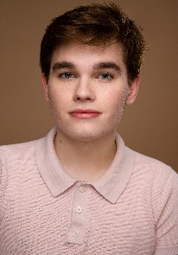
GRAYSON MALLON
-mallongrayson82@yahoo.com- -Graysonmallon@insta-
HEIGHT: 5’7
VOICE: TENOR
THEATRE
Sound of Music Friedrich Patterson Mill High School
MacBeth Angus Patterson Mill High School
Footloose Lyle Patterson Mill High School
Dentity Crisis Mr. Summers Patterson Mill High School
Grease Ensemble Patterson Mill High School
Elf Buddy Dance with Me Academy of Dance
Seussical Cat in the Hat Dance with Me Academy of Dance
Newsies JoJo Streetlamp Productions
Matilda Michael Wormwood Streetlamp Productions
Joseph Zebulun Patterson Mill High School
Romeo and Juliet Peter Patterson Mill High School
Newsies Henry Children’s playhouse of Maryland
Les Misérables Enjolras Griffin Theatre
Addams Family Ancestor Tidewater Players
13 Malcolm Dance with Me Academy of Dance
Lowball Jared School for Visual Arts
EDUCATION
AMDA, NY
Acting: Brian o’ Niell, Julia Martin, Michael Blatt, Hayley Palmer, Michael Hauschild
Voice: Sharla Nafziger
Dance: Katie Harvey, George Nieves, Jimmy Kichler, Christine Cheung, John Alix, Elizabeth McGuire Cynthia Murray-Davis, Michelle Bruckner, Bradley Zarr, Oren Korenblum, Rebecca Arends, Carisss Fiorillo, Beatrice Howell
Musical Theatre: Kyle Taylor Parker, Kristen Mengelkoch, Brigid Brady, John Saunders, Eric Shorey, Eric Van Tielen
SKILLS
Tap/Jazz/Musical/Ballet dance experience, cooking and baking, gamer, tech swavvy, animal lover, improv

