

Credits  
  
Gilly & Keeves  
Weasley Man / Rally Supporter  
Booklight, Philadelphia, PA. May 2022  
  
JG Wentworth Troupe   
Cashier  
Dan Hertzog, In the Wee Hours, New Hope, PA. September 2022  
  
Show Me the Body, “We Came to Play”   
Actor, “Riot Police / Mosher”  
Zev Deans, Philadelphia, PA.   
September 2022  
  
SPiN, “Dreaming”  
Actor, “Student Bully”  
Jim Vacca, Bryn Athyn, PA.  
September 2022

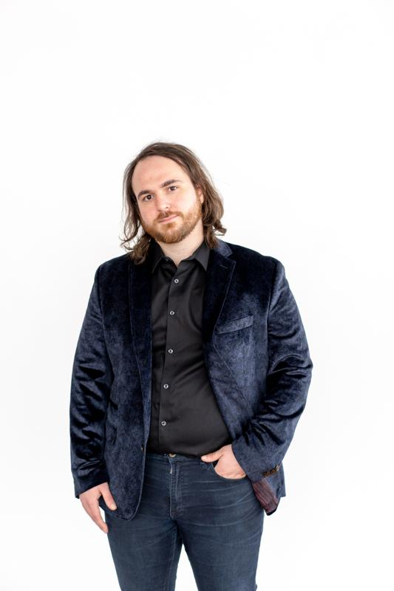  
Contact  
Email: rjtbucher@gmail.com  
Cell: 215-208-8975  
  
Demographics  
Age Range: 25-40  
Ethnicity: White / European Descent  
Height: 5’8”  
Weight: 220 lbs  
Hair Color: Brown  
Eye Color: Brown