``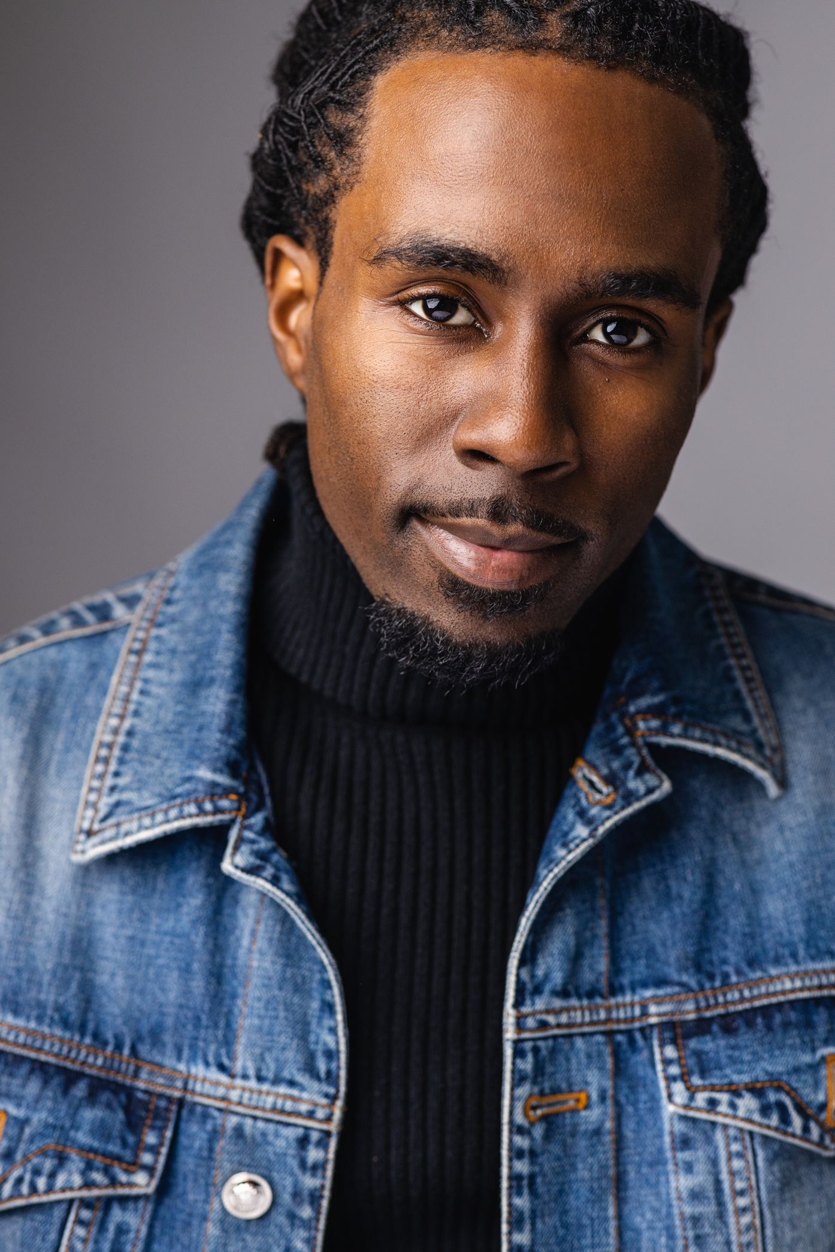

Clifton Heyward
Atlanta, Ga | 770-891-4960 | clift.heyward@gmail.com
HEIGHT: 5’8 WEIGHT: 140 HAIR: BLK EYES: BRWN
SHIRT: MED SHOE: 8 PANTS: 30/32

FILM/TV

Bad Boys For Life Biker/Stunts/Shoot Mike Gunther / Andy Gill

They Cloned Tyrone Actor/ “Gold Grill” Juel Taylor

Hammermill Commercial Soccer Player Hammermill Paper

Adidas Forum Biker/Stunts Klaudia Clouds

Reebok Commercial Biker/Stunts Motion Family

All the Queen’s Men Biker/Stunts Yan Dron

Mayor of Kingstown Biker /Stunts Jesse Haus

Freaky Tales Biker / Stunt Double Ron Yuan

Freaky Tales Utility Stunts Norbert Phillips

Holiday Road Precision Driver Leesa Pate

SKILLLS
- DIRTBIKES OFFROAD/STREET
- ATV OFFROAD/STREET
- WHEELIES
- STUNT DRIVING
- SWIMMING
- HORSE RIDING
- CAR SLIDES
- CRASHES
- RAPELLING
- SLOW WHEELIES
- FIRE WALLS
- MODELING
- BOXING
- PRECISION DRIVING
- RAP
- RIGGING
- UTILITY STUNTS
- FAST LEARNER
- SOCCER
- ACTING
- FALLS
- DRIFT
- FIGHT
- SHOOT
- BASKETBALL
- FOOTBALL
- BOW AND ARROW
- BASEBALL
- SKATING
- MOTORCYCLES (STREET)

