**Caitlyn De Luca**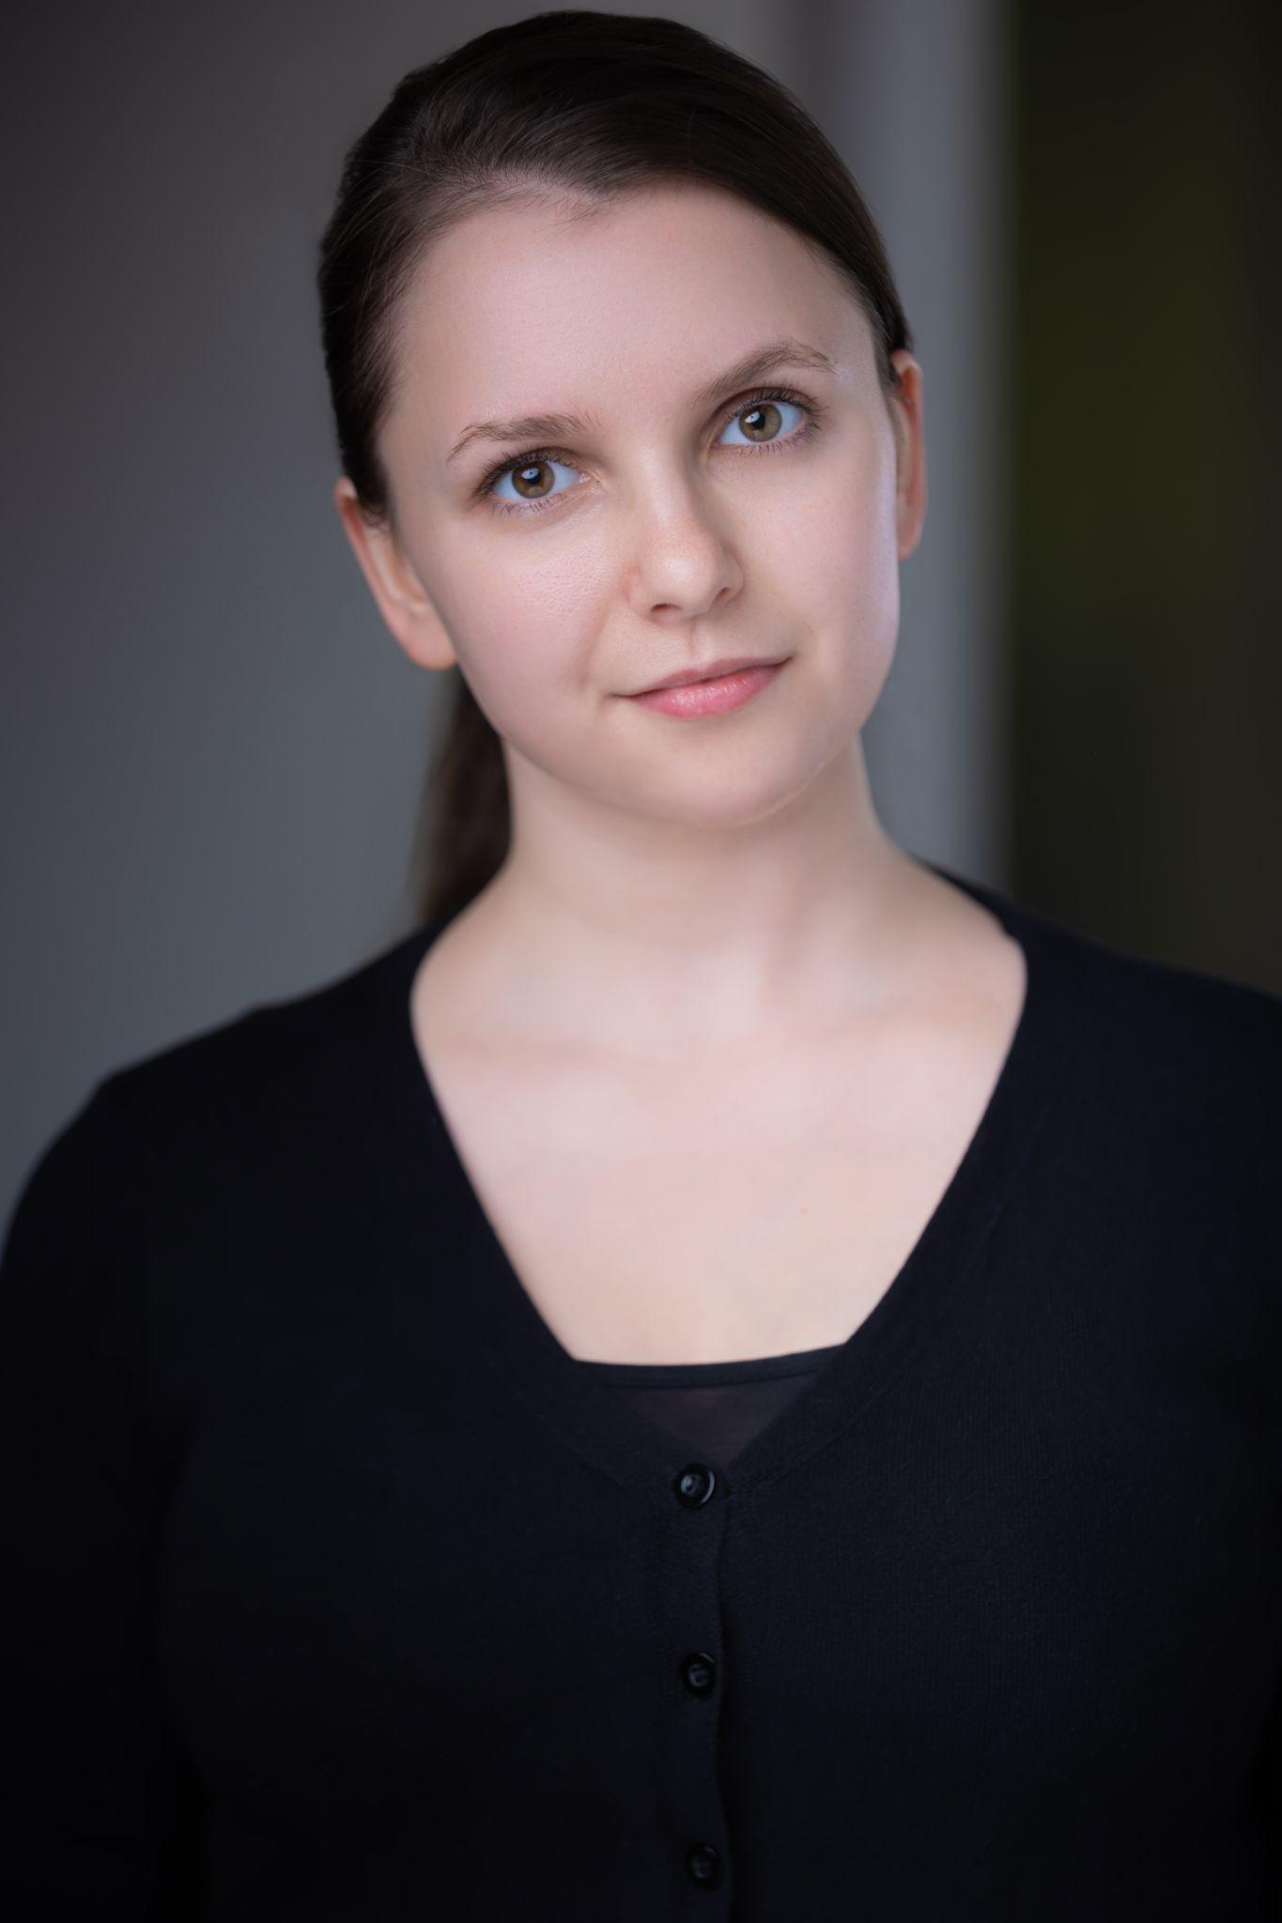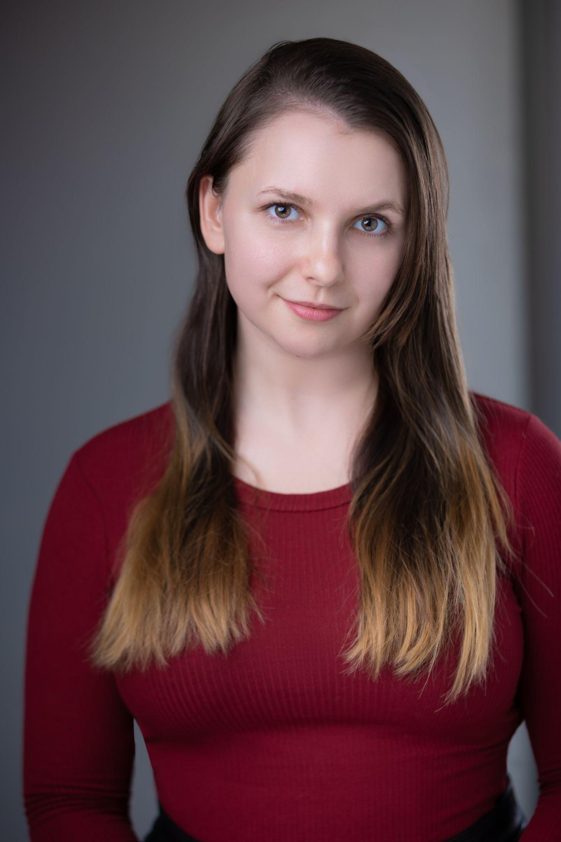

(Professional Name)

Phone: (240) 210-4359 (Best Contact)

Email: [caitlyndeluca2022@gmail.com](mailto:caitlyndeluca2022@gmail.com)

##### **THEATER CREDITS** (Partial List)

*Harvey* | Myrtle Mae | St Mary’s Ryken Drama Department

*Joseph and the Amazing Technicolor Dreamcoat* | Lead Narrator | St Michael’s Performing Arts

*Honk!* | Snowy | St Mary's Ryken Drama Department

*Once on This Island* | Villager/Beauxhomme | St Marys Ryken Drama Department

*Grease* | High School Student | St. Marys Summerstock

**PERSONAL STATS**

*Height*: 5’ 4.75” *Weight*: 145 pounds *Age Range*: 16-35

*Eye color*: Hazel *Hair color*: Brown *Hair Length*: Long

**MISCELLANEOUS**

UNION AFFILIATION: Non-Union

SPECIAL SKILLS (Partial List):

(Intermediate to Advanced) *Etiquette;* *Equestrian - English; Running, General; Weight Lifting; Comedian; Stick Shift Driving; Manual Driving; Ballroom; Hip Hop; Line/Country*

(Voice) *Vocal Range: Mezzo Soprano; American - Standard/General Accent; British - BBC English Accent*