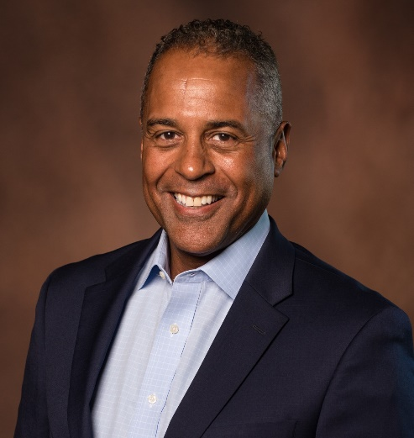

*Name:*   **LOWELL PERRY**  
*Contact:*  615-305-1693 [Lowell.Perryjr@gmail.com](mailto:Lowell.Perryjr@gmail.com)

*Special Skills*:   
Ear-Prompter and Tele-Prompter advanced. Broadcasting, live narration, public speaking and character impressions. Extensive print credits. Golf, basketball, football, yoga, pool, and gourmet cooking. Speak and understand some Spanish.

*Stats:* 6’ 1” – 195 - 42L - 16-34 – 33/34 – 11D

Additional Attributes:   
Height: 5 ft. 10 in., Weight: 160 lbs.

**FILM & TELEVISION**

Nashville Featured/Lawyer ABC

Drop Dead Diva Featured/Dr. Levenson Lifetime

Nothing But the Truth Featured/Federal Marshal Yuri Films/Rod Lurie

Déjà vu Featured/Reporter Bruckheimer Films

The Real Sting Featured/Jonathan Sting LLC

The Paraclete Featured/Derrick Immigrant Films

For Love or Money Street Hustler Concierge Inc.

**COMMERCIALS**

Blue Cross Blue Shield Featured/Dad BCBS TN

Direct Insurance Featured/Spokesperson Filmhouse Prod.

Toyota Featured/4 Runner Strader Films

Tennessee Lottery Featured/Winner Gish Sherwood

CCA Featured/Spokesperson Comp. Media

Memories – 20th Century Past Featured/Host Comp. Media

**INDUSTRIAL FILM/VIDEO**

UAW Ford Narrator/Spokesperson RFG Productions

Chevrolet “Truck Track” Narrator/Host Kent Films/Schmier

The Gideons “IEM” Narrator/Host Comp. Media

Chrysler “Master tech” Narrator/Host Tele-video Prod.

Comerica Bank Narrator/Spokesperson ERP

Whirlpool Narrator/Spokesperson Jan Hughes Prod.

**RADIO/VOICEOVER**

KFC (Various Spots) Announcer Alan Frank/Lilac

McDonald’s (Various Spots) Announcer Arnold Comm.

Bisquick Featured/Dad Don Coleman Assoc.

Greektown Casino Featured/Stockbroker RMS Prod.

Dodge Truck Announcer Pentamark World.

Henry Ford Health Systems Announcer Alliance Music Prod.

General Motors “50’s & 60’s” Announcer/Narrator GM Communications

**TRAINING**

On Camera Acting Allison Roth

Actor’s Improv Workshop Kim Carney