Chacha Berroa 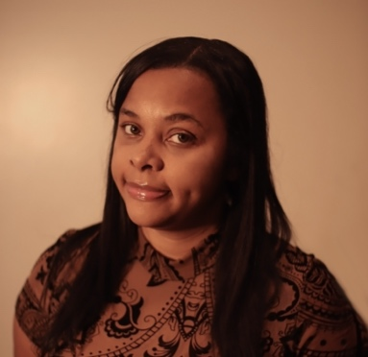 c: 347-444-2760 e: cassandragberroa@gmail.com
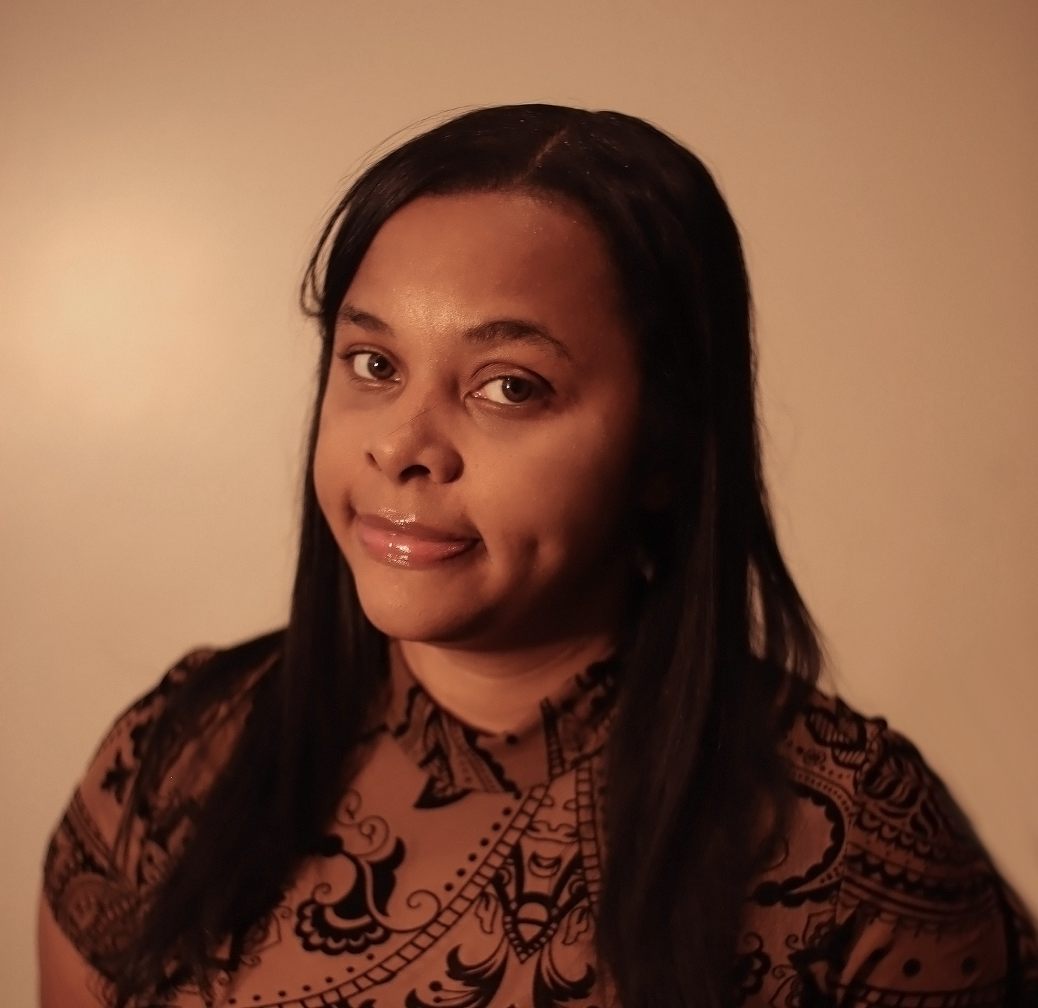

Acting Resume

PERSONAL SUMMARY

A motivated, committed and talented actress with strong stage instincts Chacha is committed to achieving the highest standard of performance and is always willing to listen and learn from others.. She is energetic, prepared to ‘go the extra mile’ and is sure to make a real difference to any project she is involved In.

CREDITS

Theatre
• The Little Mermaid |  | Chorus line | 2008
 | KEY SKILLS & COMPETENCIES

AREAS OF EXPERTISE

Voiceovers

Regional Accents

Fluent Spanish

Music & dance
Alto Singer |  | Mezzo Soprano | Merengue  Reggaeton

Dialects
Latina |  | Southern | New Yorker

Academic Qualifications  Relay University MA HONORS ENGLISH (2019) | 2017- 2019

PERSONAL DETAILS

Height; 5ft 2inches

Weight; 165 lbs.

Build; Curvy full

Eyes; Brown

Hair; Black

Age: 29

Role ages; 22 – 35

