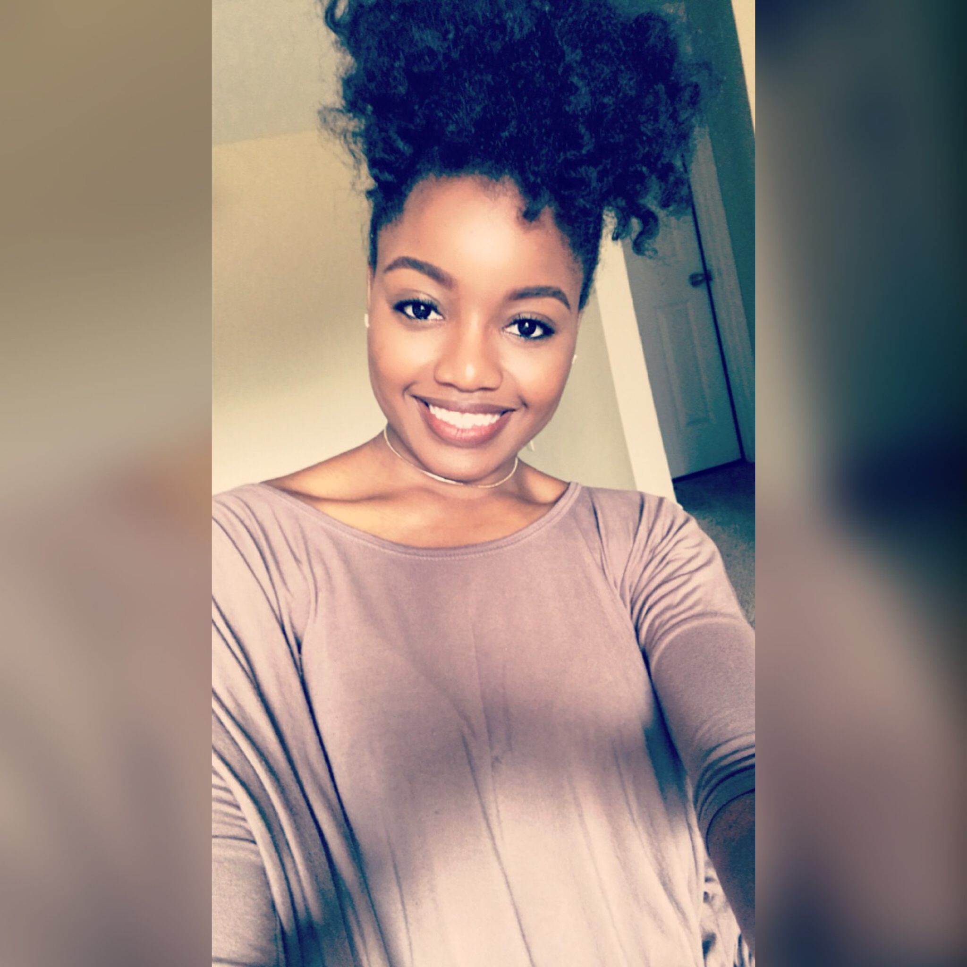

-**Trianna Jones**

**Mobile: 901-438-1275**

**Email:** [**triannaj@gmail.com**](mailto:triannaj@gmail.com)

**Summary:** Enthusiastic and enchanting personality in search of opportunities that will allow me to utilize the skills that I have learned over the years to investigate, inform and/or amuse others. A strong communicator, striving for professional excellence. I'm looking to grow in an environment relevant in talk show hosting, broadcasting, communications, media/public relations and film.

**Experience**:

**-**Casted in Netflix series “Uncorked” —Small non-speaking role

-Casted in a Farmer’s Bank Commercial – Background talent

-Casted in a Netflix movie, “The Old Story” – Background talent

-Casted in the television show, “Nashville” – Background talent

-Casted in a biopic film, “The Brian Banks Film” – Background talent

-Casted in a short film, “The Omnious Project” – Supporting Role