Monet Shaw 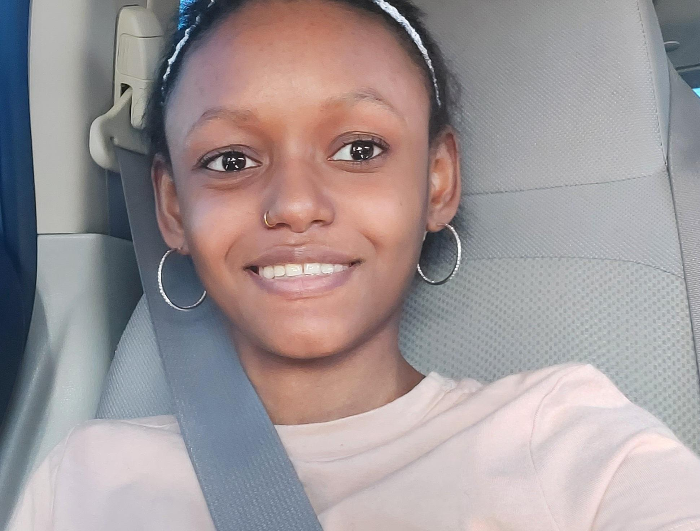

Las vegas NV

**(313) 300 - 2841**

**Monet0415@gmail.com**

# Bio

Eye color: Brown

Height: 5’1”

Hair color: Black

Weight: 72 Ibs

Age: 17

Disability: Left arm amputated

# Theater

* Aladdin Jr. Winedoint Ensemble 2017

# Tv/ Movies

* Andy the taking hedgehog Extra 2018

# Modeling

* Fashion show - 2017
* Arabella fashion show - 2023

# Education

High school - Graduating in 2024