Devin Graham

Artist| Model| Actor| Content Creator

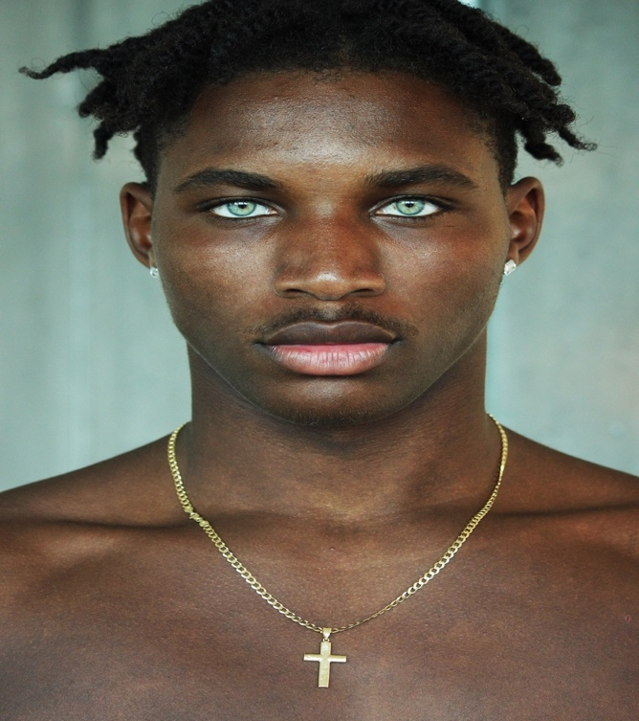

# Summary

As a multi-talented artist, model, and content creator, I bring a unique and dynamic skill set to the table. With a passion for what I do and goals i've set for myself, I have built a strong online presence and a loyal following. My diverse background and experience with marketing in business will obtaining a bachelors in business while using that for online purposes as well in social media separates me being a knowledgeable talent.

# ObJECtive

Seeking representation as a talented and versatile artist, model, and content creator by a reputable talent agency that shares my passion for creativity and strives for excellence in the entertainment industry.

# Skills

* Creativity across multiple mediums, including modeling, acting, and content creation.
* Strong understanding of social media platforms, influencer marketing, and audience engagement strategies.
* Excellent interpersonal skills, with the ability to connect with diverse audiences and build relationships.
* Professionalism, reliability, and dedication to delivering high-quality work.
* Ability to collaborate effectively with a team and adapt to different environments and projects.
* Strong organizational skills, with the ability to manage multiple projects and meet deadlines.

**Experience**

* Created visually captivating content for various social media platforms, including Instagram, YouTube, TikTok, etc.
* Utilized creative skills to develop and execute creative concepts for photoshoots, videos, and other visuals.
* Built a loyal and engaged following through consistent and high-quality content creation, resulting in [220k] of followers on tiktok as well as 21k on Instagram.
* Total amount streamed (Apple Music) - 4.1K (Top 5 cities) -  
  1. Cape Coral, FL 2.Miami, FL 3.Tampa, FL, 4.New York City, NY 5. Orlando, FL
* Total amount streamed (Spotify )- 126,519 “No Love Lost” (mixtape) - 34K  
  (Top 5 cities, month of August )  
  1.Seattle, 2.Fort Myers, FL 3.Miami, FL 4.Paris, France 5.Meadville, FL
* Total views (Youtube)- 10,981
* Collaborated with brands and participated in sponsored campaigns, showcasing products in a creative and authentic manner.
* Maintained professionalism and positive relationships with clients, fellow artists, and collaborators.

**COLLABORATIONS**

● Modeling Agency @Thesourcemodels (Miami)

● KineticKings

●TrendHim

● JerseyNation

● Icegiant

● Streetwear

● ShopGld

● HipHopBling

●PSD Underwear

● Crwnbody

● Grateful-apparel

● Nova-shine

● Sprayground

● Camilawithlove

● Bikini Beach Au

● Swim Week

● I AM EYE

● Crysp Studio

● Mix Master Miami

● Enfantmondain

● Creatyler (Utopia project) <https://youtu.be/QzZrA3YaJuM>

● Tropical Smoothie Commercial Ad

● Victor Mudhe Clothing Line (Portugal Brand)

**lINKS fOR rEFERENCES**

Instagram Portfolio: <https://www.instagram.com/devodontcapalot>

TikTok Portfolio: <https://vm.tiktok.com/ZMJajkRkM/>

Every website: <https://linktr.ee/devodontcapalot>