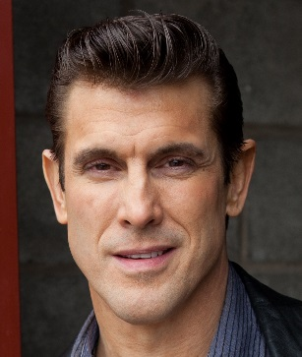**DIRK PANOZZO**

Hair: Brown

Eyes: Brown Email: [dirkp1@ymail.com](mailto:dirkp1@ymail.com)

Height: 6’ 2” Cell: (815) 263 - 3475

Weight: 204 (fit) lbs. Business: (815) 932 - 7526

**FILM/TV/NEWMEDIA**

The Goat Lead Dir. Justin Wegner

Secret Lover Supporting Shad El-Amin / El-Amin Studios

Chicago P.D. Featured Dick Wolf / NBC

Industrial Cleaning Product- Lead Dir. T. W. Li

Commercial

**THEATRE**

“What Lies Beneath” Dad (Supporting) Michael Pieper / Second City Chicago

“Critical Condition” John (Lead) Michael Pieper / Second City Chicago

“Lights Out” Wilmer Price (Lead) Michael Pieper / Second City Chicago

**TRAINING**

Acting Hank Hilberth, Michael Pieper

Improv Brian Posen

Physical Comedy Anne Libera

**SPECIAL SKILLS**

Boxing, Martial Arts, Can Impersonate People, Animals, & Sounds, Physically Fit, Many Odd Physical Anomalies (i.e. wiggle ears, extend shoulder blades, burp on command, & many more), Very Animated Expressions, Horseback Riding, Amateur Bodybuilding (steroid-free), Bartending, Bartender Flair, Special FX (applying & wearing), Can Drive Manual Transmission, Kayak, Karaoke, Intermediate Guitar, Move & Speak Like Elvis Presley.