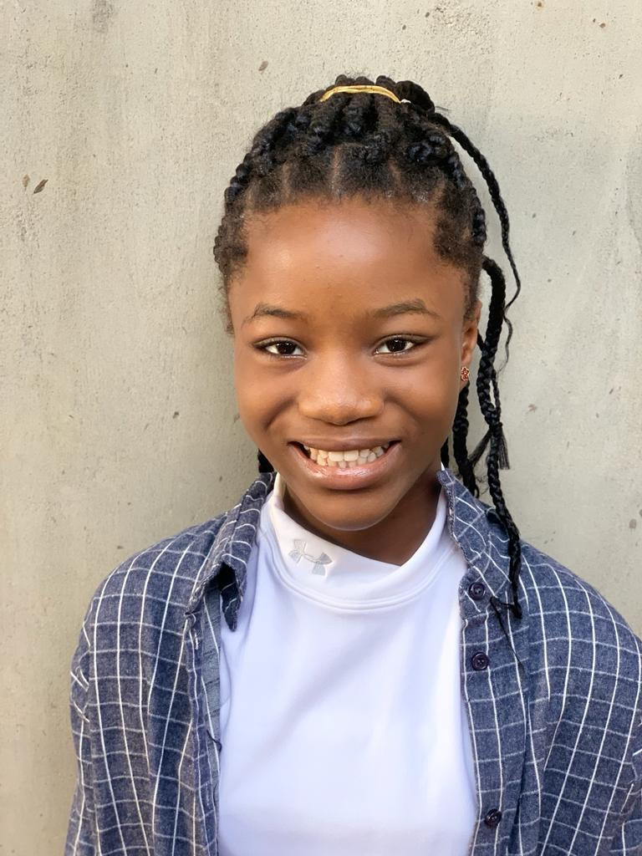

TEMILOLUWA ADEBISI (NON-UNION)

**CONTACT:** 08034619748

**EMAIL ADDRESS:** [adebisitemi11@gmail.com](mailto:adebisitemi11@gmail.com)

**PHYSICAL ATTRIBUTES**

**Height:** 5’11

**Weight:**

**Eye Color:** darkish purple

Hair Color: darkish brown

**SPECIAL SKILLS**

Writing, Acting, Vocal Range: Alto and Treble, Dancing, Rapping

**THEATER**

**TITLE *CHARACTERS NAME *PRODUCERS**

The Pastor’s daughter ALLY TEMILOLUWA ABIOLA

The Killer AILA ADEOLUWA SALAKO

Follow God COMFY ADEBOLA HEPHZIBAH

The Two Families DEBORAH TEMILOLUWA ABIOLA

**REFREES**

MR KEHINDE ADEBISI- Engineer