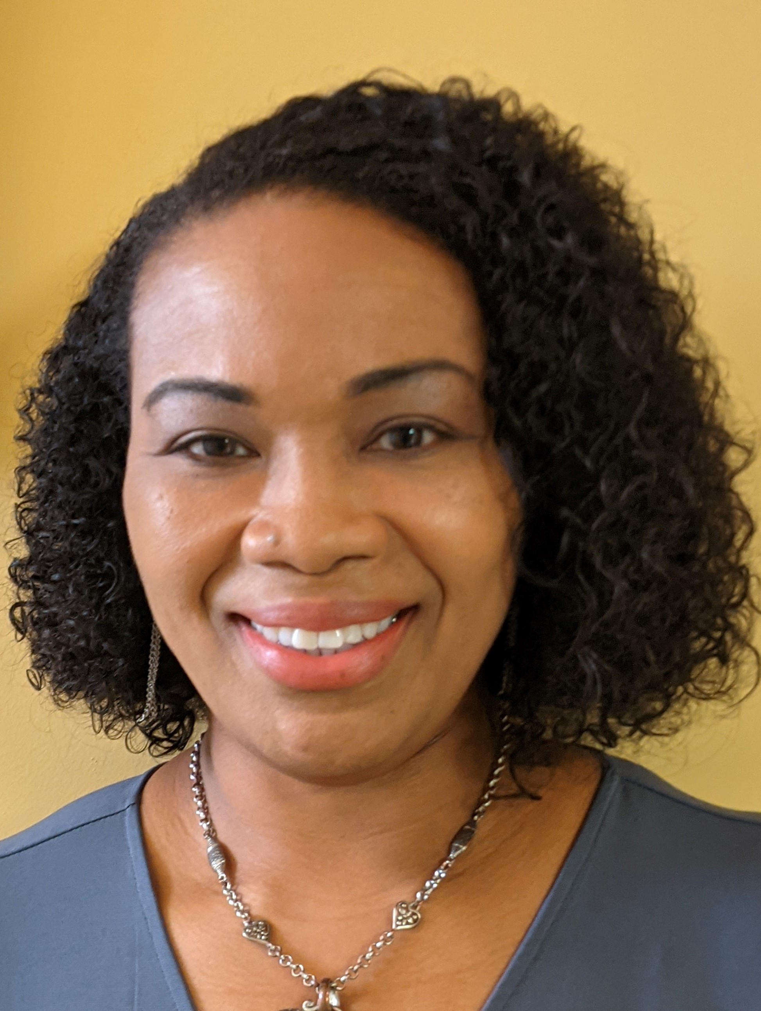
Katrina D. Robinson
(804) 337-2550 (c)
Kdrobinson_76@hotmail.com

Height: 5’5” Weight: 225 Bust: 44” Waist: 42” Hips: 48”
Hair: Black Eye: Brown Bra: 40 DDD Dress: 16-18 Role-playing age: 35-50

Film
A Simple Request Dr. Rose J. Madison Productions
One Last Chance Dr. Rose J. Madison Productions
Love Affair Tracy Medial Center TV
Choices Jordan’s Mom Moonlight Comm/7 Bridges
Death of the Black Widows Dt. Robinson BDD Ent/John T. Robinson
Mama’s Baby Boy Lauren BDD Ent/John T. Robinson
Black Widows Dt. Robinson BDD Ent/John T. Robinson

Television
Josh & Lauren (Untitled) Stand in/Lily TW Cast & Recruit
Please Don’t Destroy Stand in/Taylor Gloss Mountain Prod LLC
For My Man Jeri Woods/Lead/Perpetrator TVOne/Sirens Media

Theater
Through Their Eyes Heartbroken Mother Amplified Frequency Productions
Through Their Eyes Widow on Trial Amplified Frequency Productions
Love, Fight, Win Danny Bradley Two5M Productions
Not the Man I Married Tasia Michelle Lee Productions
Martin, Malcolm, and We Angela Brown Raw Talk Entertainment
When Love Is Not Enough Michelle Raw Talk Entertainment

Special projects/Commercials
Where Love Gathers shoot Nurse Cry Film & Production
Voting Promo Poll worker
Carmax Commercial Volunteer Liquid Talent Group
Good Feet Commercial Shoot Dancer/Interviewee Impatient Cow Productions
UCDavis MBA Roleplay Patient 2 2U Inc
Progressive Political Shoot Supporting 76 Words/Tag Cinema
Hampton Tourism/Rosie’s Featured couple Vacation Channels/LTG
Progressive Political Shoot PSA Reader 76 Words/Tag Cinema
Flackers Flax & Fonio Commercial Taylor/Supporting Inexplicable Productions
Hampton Tourism Shoot Wife Liquid Talent Group
Nest Realty Commercial Shoot Wife/Buyer Liquid Talent Group
Instructional Video Ayita/Mother WriteBrain Films
Instructional Training Video Employee Dupont/Jpixx
Air National Guard Commercial Nat’l Guard Recruiter Rebel Casting
Instructional Training Video Inspector/Supervisor Dupont/Hutson Talent
Virginia 811 Commercial Wife/Homeowner Access Advertising

Education/Training

2013 Wright Model and Talent Agency
Speech and Theater workshop
Acting Technique for Film and Advanced Scene Study coursework
Speech and Theater workshop
Character development workshop

2007 Strayer University, Richmond, VA
Bachelors of Science
Information Technology

2000 Virginia commonwealth university
Bachelors of Science
Emphasis on Business
Information Systems

LINKS
www.resume.actorsaccess.com/KatrinaRobinson
www.backstage.com/KatrinaRobinson
www.facebook.com/katrinad.robinson1
https://www.facebook.com/KAT-Plus-Model-Actress-Entertainer-452655621449407
www.instagram.com/kdr1976
www.tiktok.com/katrinarobinson912

Local Hire: VA, MD, DC, NYC, NJ, PA, GA, NC, SC. Current Passport and Driver’s License

