**Aryan Sharma**

First Year Student at UBC Vancouver. *

  
  
  
Professional Summary:   
  
First year student at The University of British Columbia. Pursuing a double major in Theatre and Psychology Interested in theatre/camera acting, monologue delivery and film making! Along with studying Psychology & Human Behaviour. Exceptional at utilizing attention, memorization, and improvisational abilities during performances. I am an extremely motivated, reactive, and empathetic performer and have taken part in many commercials, stage and short film productions.  
  
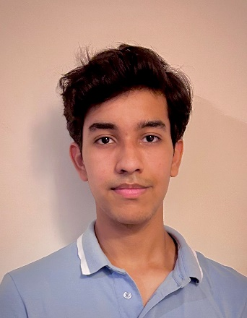  
  
  
  
Relevant Coursework:   
  
Psychology, Human Behaviour, Sociology, Theatre, Family Studies.  
  
Clubs and Honours: Member of Performing Arts Council and Outreach Council in Vasant Valley School. Member of Drama Club in Vasant Valley School. Member of The AMS Cricket Club at UBC.  
  
**Grades:**   
Vasant Valley School Class XII Final Board - 90 % or A +  
IELTS Result – 7.5 Band out of 9.0  
  
Theatre: Performed plays for Acting Studios and performed more than 30 plays for School in both Lead Role and Direction.  
  
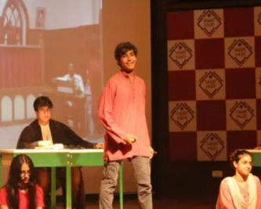  
  
Additional Skills:  
  
 ~ Media Intern with the India Today Group ~ The largest media and television house in India. Spearheaded the 'India Today Group' as an intern in their media department and made a citizen journalism project about 'Price Rise' and 'Inflation' in India.  
  
 ~ Partnered with the Fortis Hospital where I tried to understand the different domains of Psychology and how it impacts young ones  
  
~ Completed an online course from Ashoka University on Politics, Law and Judgement which helped me in making a project about why and how the laws work the way they do and how we as citizens are supposed to abide by them.  
  
A few Performances by Aryan  
  
Live Performance Online (Monologue Delivery) in a worldwide Talent Show ~ <https://youtu.be/XRu-d-EcXSA>  
  
Shutter Island – A Person’s Psyche and Sanity (Short Film) ~ [Shutter Island | The Truth about Andrew Laeddis | Recreation - YouTube](https://www.youtube.com/watch?v=y8uALB_ChHg&t=1s)  
  
Haider’s Political Speech. (Live performance in front of more than 400 people) ~ <https://youtu.be/YKl6cllEw9I>  
  
The ‘Martin Kove’ Audition for the role of ‘Young John Kreese’  
 ~ <https://youtu.be/5ULqNGPp-5Y>  
  
Macbeth’s Monologue from ‘The Tragedy of Macbeth’ by William Shakespeare ~ <https://youtu.be/816IONXlf94>  
  
Aldo Raine’s Speech from Inglorious Basterds  
 ~ <https://youtu.be/rbmWYUCNynY>  
  
A Short Film made by Aryan Sharma (Miles To Go Before I Sleep)  
~ <https://youtu.be/O4_NRHVm4u4>  
Awards   
  
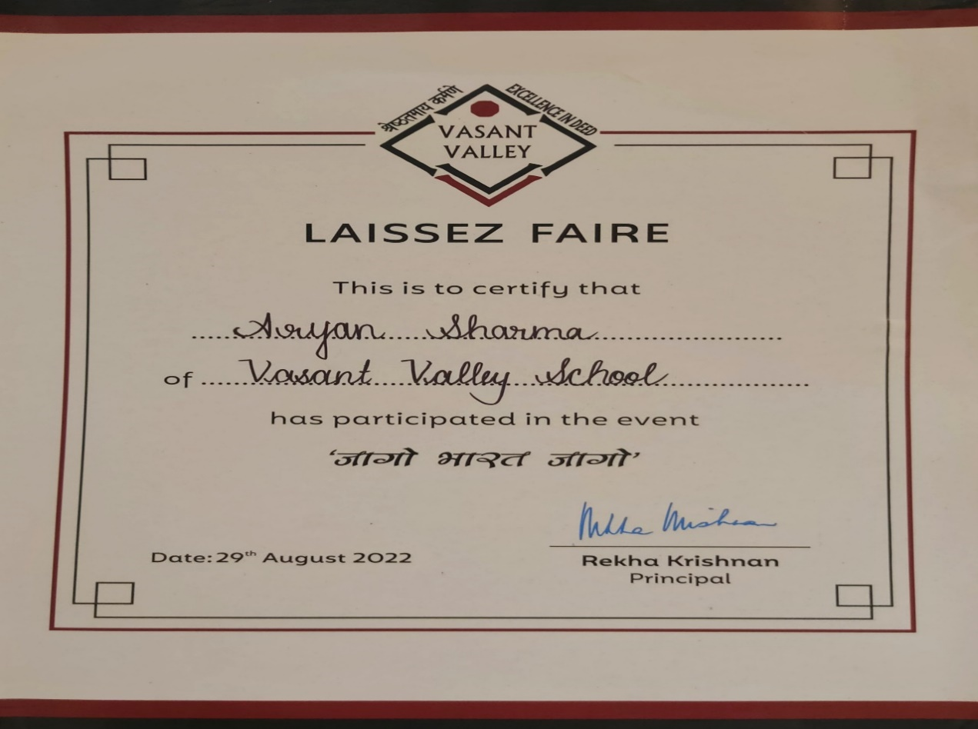  
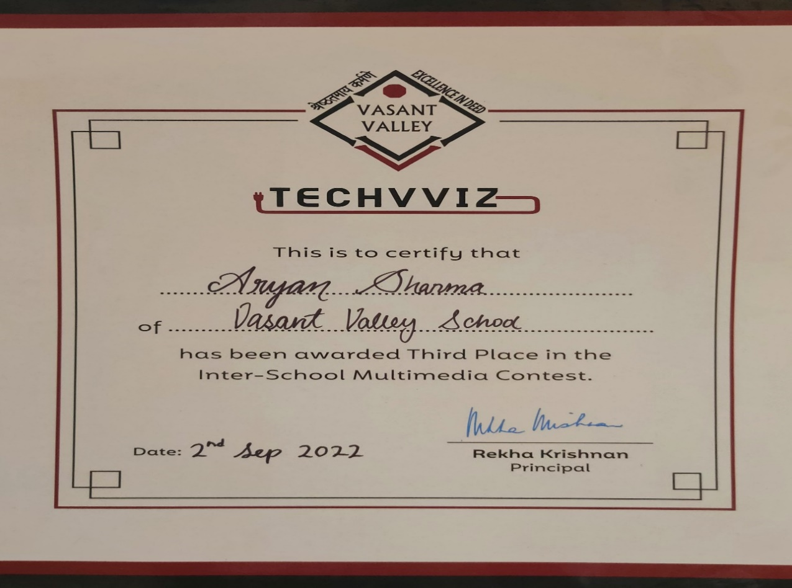  
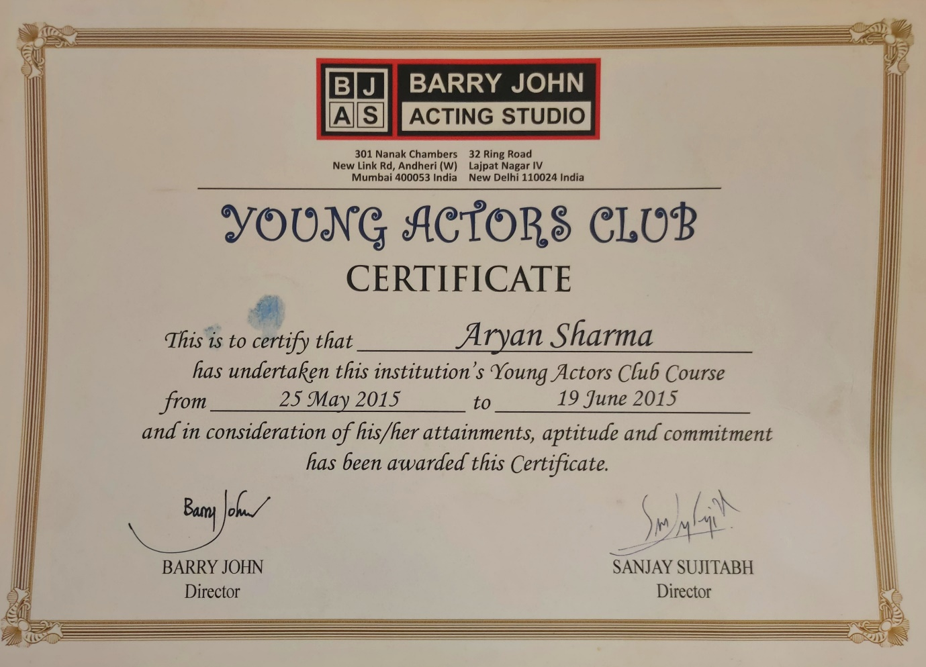  
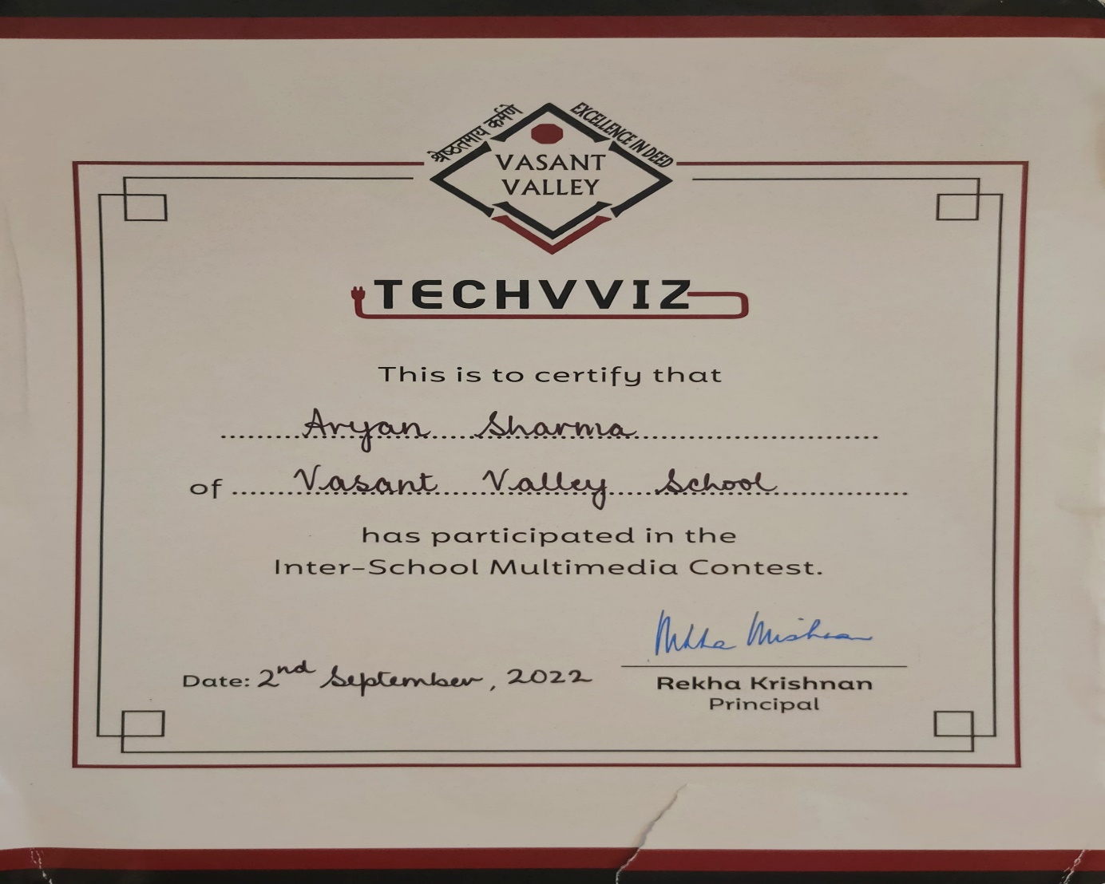  
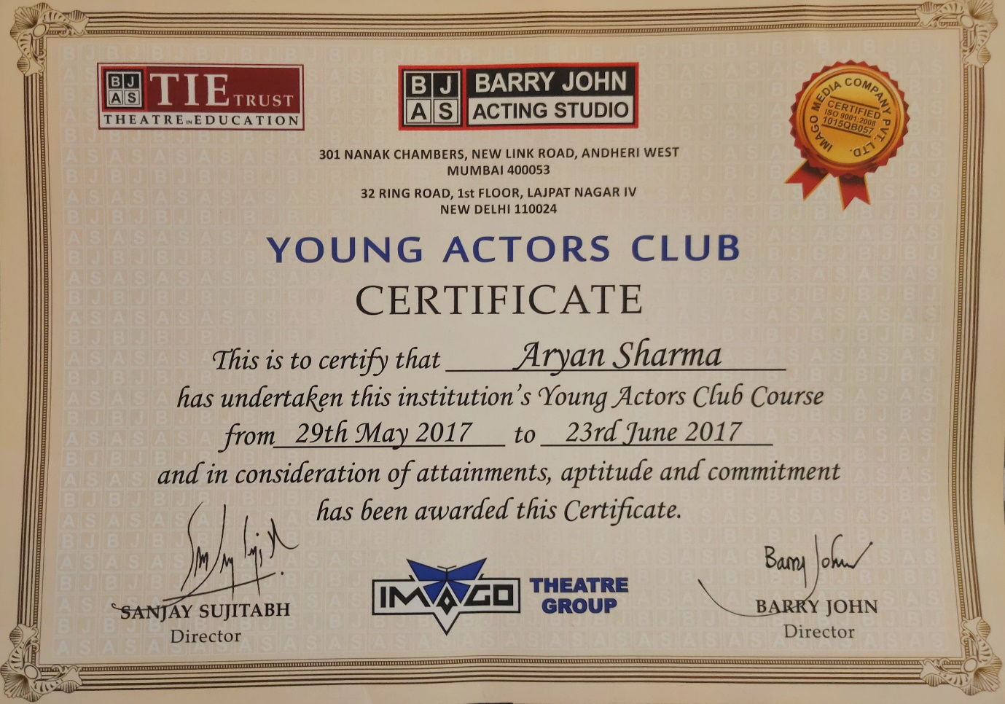  
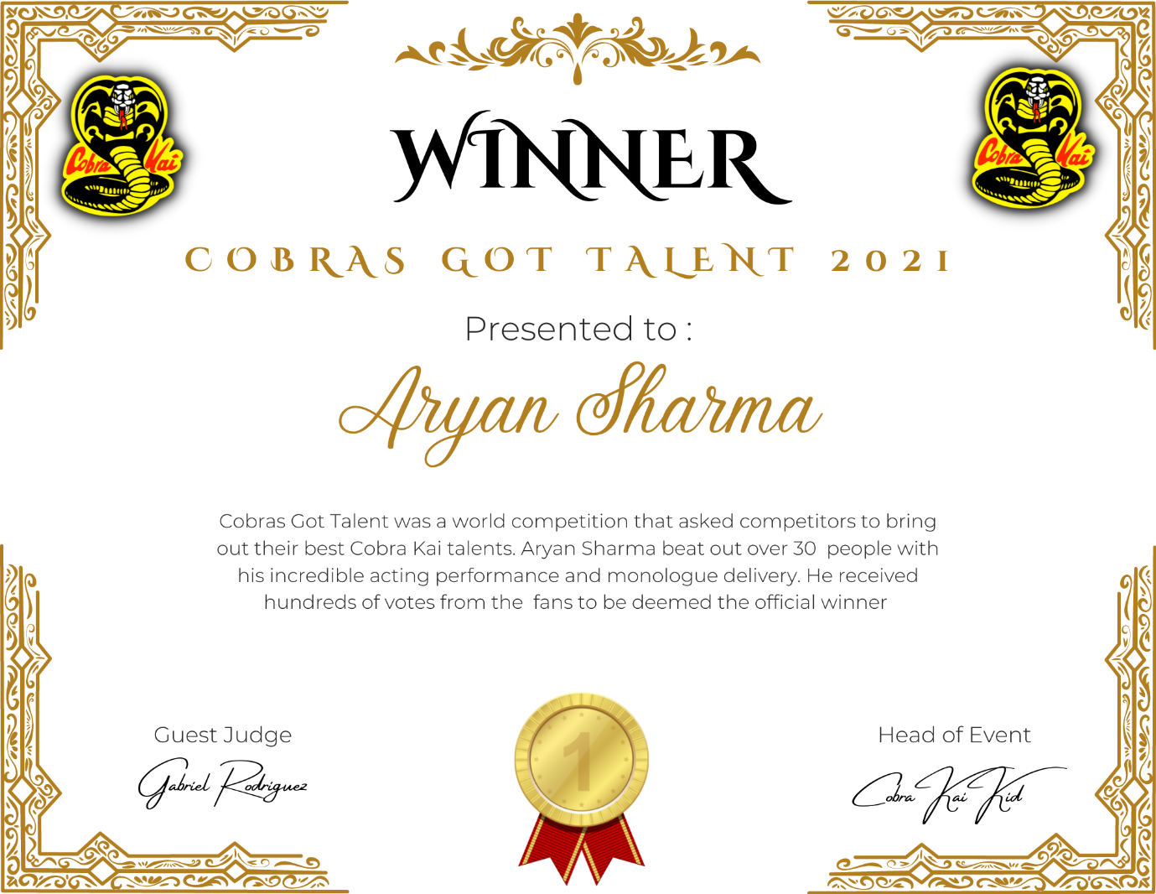  
  
Achievements & Recognitions  
  
 **Got selected by ‘The American Musical and Dramatic Academy’ for ‘BFA’ in Stage Acting with an Institutional Scholarship of 30,000 $.  
  
Got selected by ‘Whistling Woods International’. Considered as India’s Top Film Institute.  
  
Won the 2nd Place at Vasant Valley’s ‘Anjalika Kapur’ Drama Competition for the ‘Monologue’ and ‘Musical’ creation category.  
  
*\*~~~~~~~~~~~~~~~~~~~~~~~~~~~~~~\****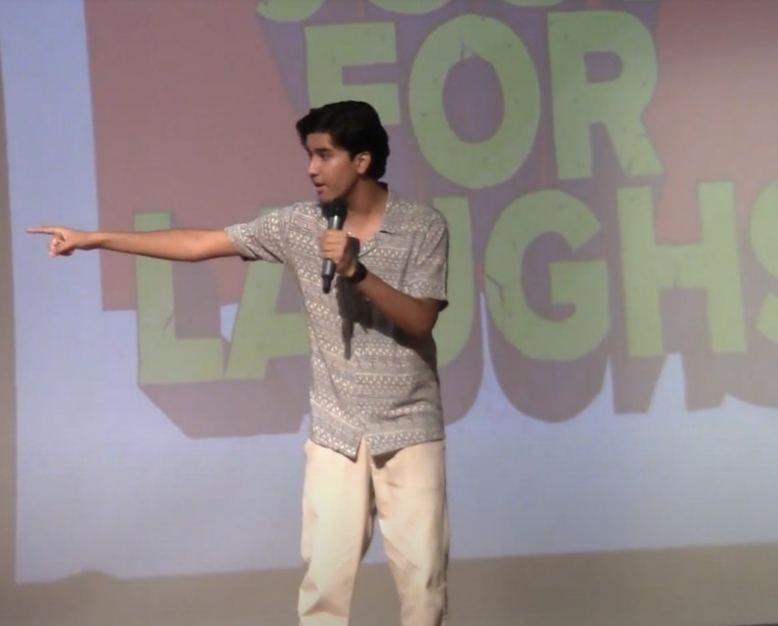Dedicated and driven learner with excellent people skills and solo experience in the field of psychology and stage acting. Strong attention to detail, continuously striving to learn new techniques and work as a team to improve and create a positive impact on the overall goal or performance  
  
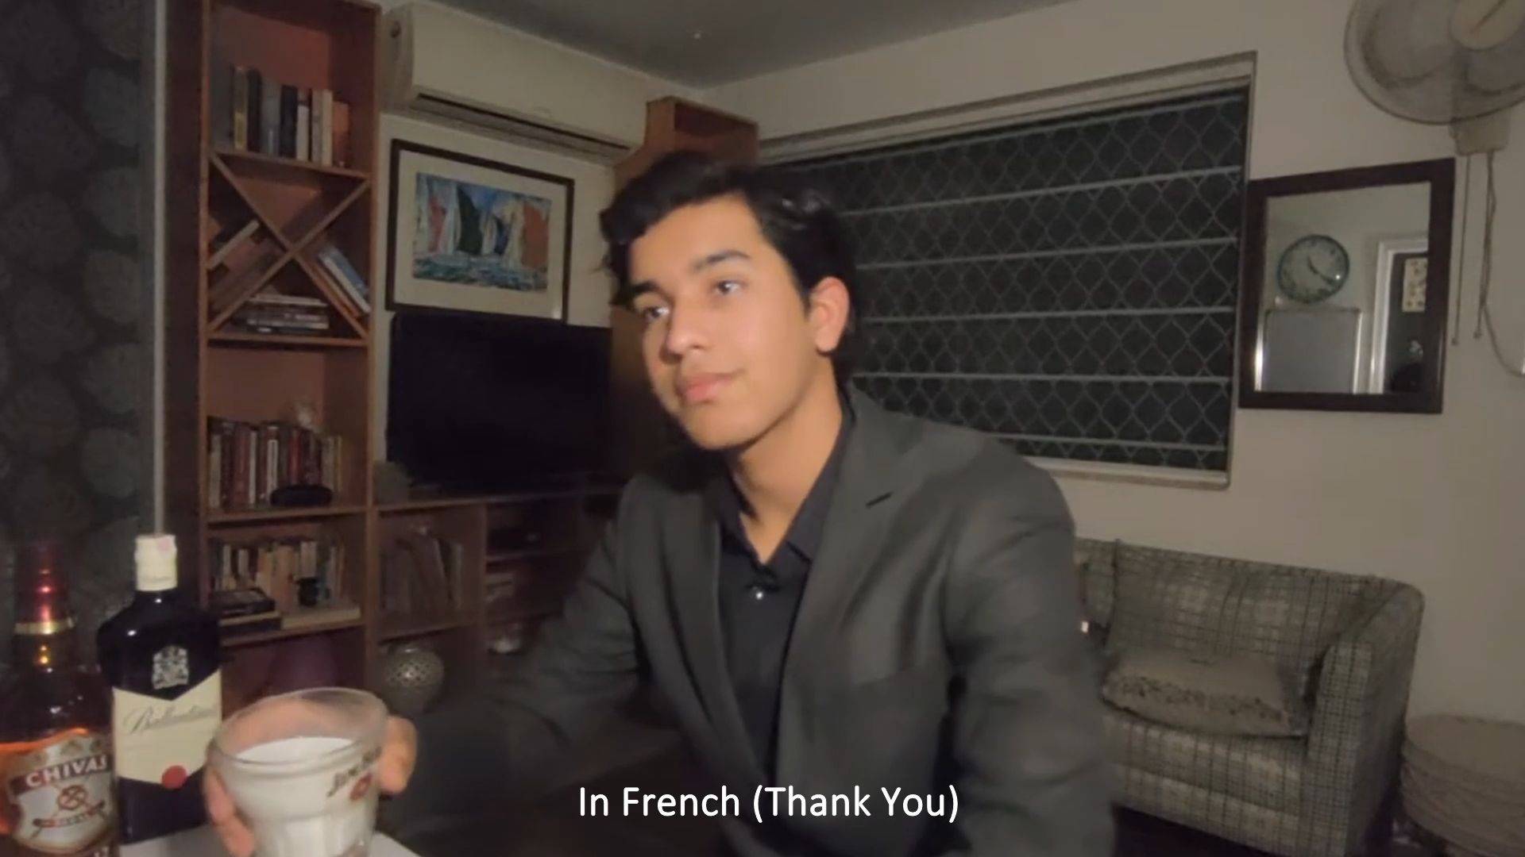  
  
  
CONTACT:  
  
[aryansharma29115@gmail.com](mailto:aryansharma29115@gmail.com)  
  
+1 236 (777) 8402  
  
Vancouver, BC.