Jazmin Chehin

Actress

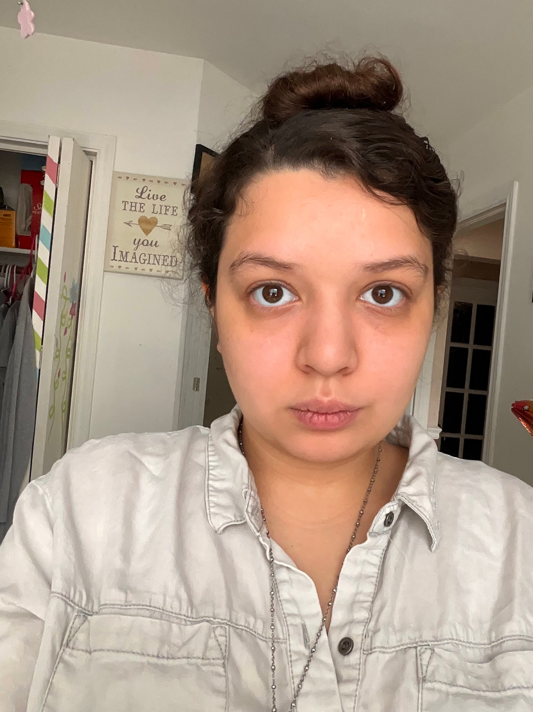

Personal Information
Email Phone
Chehinjazmin@gmail.com (512) 713-6237

Address
12303 Farnish Cv
Austin, Tx 78753

Education
Connally High School

Bio
Eye Color: Brown

Hight: 5’4’’

Hair Color: Brown

Weight: 145

Body Type: Curvy

Special Skills
Languager: Native to Spanish and English

Accents: French, Spanish, British and Western.

Credits

CW’s Walker Season 2 Background Brock/ Allen Casting
Oct. 2021- May 2022

HBO Love and Death Background Brock/ Allen Casting
Mar. - Apr. 2022

AMC Walking Dead Background audio Bats BA Casting
Apr. 2022

