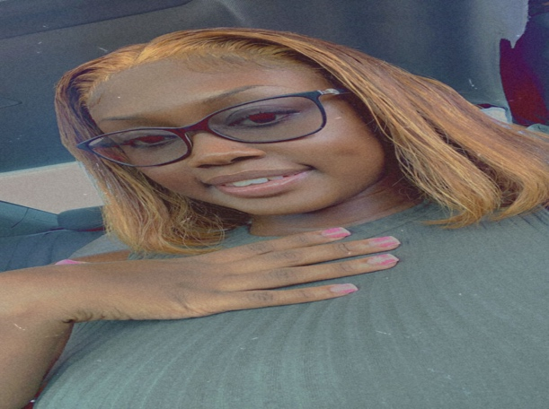 ALEXANDRIA T PENNERMAN

**Address: Flamingo Gardens #3**

**Nassau New Providence**

**Bahamas**

**Contact Info: 445-6108(cell#call) or**

**376-6741(whatsapp)**

**Email:** [**allyblossom1@gmail.com**](mailto:allyblossom1@gmail.com)

# Career OBJECTIVE

**To ascertain a highly fulfilling level of happiness and to dominate the competition daily. I aspire to be the best at whatever I do and pursue my dreams of becoming a business owner.**

# Work experience

**22nd Feb 2019-April 8th 2023**

* **Lukka Kairi Waterfront Restaurant- Cashier, Bartender,Hostess, Server**

**Oct 24th, 2021- 23rd Dec 2021**

* **Goldies -Cashier ,Bartender**

**March-September 2023**

**Ihop-Server**

**August- November 2023**

**Sugar Rush Lounge- Bartender**

# Volunteer Experience

January 15th – 17th March 2018

* **Flamingo Gardens Clinic**
* **Register General**
* **Post office**

# Education

* **Gerald Cash Primary School 2006-2012**
* **Anatol Rodgers High School 2012-2018**
* **National & casino bartending school Dec 2022**

**Bahamas Junior Certificates (“BJC”)**

* **Mathematics**
* **English Language**
* **Social Studies**
* **Health Science**

**BCSE**

* **Food & Nutrition**

# Skills

* **Customer Friendly**
* **Quick Learner**
* **Great social skills**

# Interest & AcTivities

* **Modeling**
* **Acting**
* **YouTube**
* **Dancing**
* **Designing (Drawing)**
* **Art & Craft**

# ReferenceS

**Available upon request**